China Wireless Telecommunication Standard (CWTS);
Working Group 1 (WG1);

RLC Protocol Specification


Contents
TS C202 V2.1.0 (1999-10)
Technical Specification

1. Scope 4
2. References 4
3. Definitions and Abbreviations 4
4. General 5
4.1. Objective 5
4.2. Overview on sublayer architecture 5
4.2.1. Model of RLC 5
5. Functions 10
6. Services provided to upper layers 10
6.1. Mapping of services/functions onto logical channels 11
7. Services expected from MAC 14
8. Elements for layer-to-layer communication 14
8.1. Primitives between RLC and higher layers 14
9. Elements for peer-to-peer communication 15
9.1. Protocol data units 15
9.1.1. Data PDUs 15
9.1.2. Control PDUs 15
9.2. Formats and parameters 16
9.2.1. Formats 16
9.2.2. Parameters 18
9.3. Protocol states 25
9.3.1. State model for transparent mode entities 25
9.3.2. State model for unacknowledged mode entities 26
9.3.3. State model for acknowledged mode entities 26
9.4. State variables 27
9.5. Timers 29
9.6. Protocol Parameters 29
9.7. Specific functions 30
9.7.1. Retransmission Scheme 30
9.7.2. SDU discard function 33
9.7.3. The Estimated PDU Counter 34
9.7.4. Multiple payload units and header compression 34
9.7.5. Credit and peer-to-peer flow control 35
9.7.6. Local flow control 36
10. Handling of unknown, unforeseen and erroneous protocol data 36
11. Elementary procedures 36
11.1. Transparent mode data transfer procedure 36
11.2. Unacknowledged mode data transfer procedure 37
11.3. Acknowledged mode data transfer procedure 37
11.4. RLC reset procedure 38
11.5. STATUS PDU transfer procedure 38
11.5.1. Triggers of the STATUS report procedure 38
Table 11-1: List of triggers of the STATUS report procedure. 38
11.5.2. How to act upon reception of a STATUS PDU 39
11.6. Poll procedure 40
11.6.1. Triggers of the poll procedure 40
12. SDL diagrams 41
13. Annex A Pseudo code describing AMD PDU header Compression 84
14. History 86

Intellectual Property Rights
IPRs essential or potentially essential to the present deliverable may have been declared to ETSI/3GPP. The information pertaining to these essential IPRs, if any, is publicly available for ETSI members and non-members, free of charge. This can be found in the latest version of the ETSI Technical Report: ETR 314: "Intellectual Property Rights (IPRs); Essential or potentially Essential, IPRs notified to ETSI in respect of ETSI standards". The most recent update of ETR 314, is available on the ETSI web server or on request from the Secretariat.
Pursuant to the ETSI Interim IPR Policy, no investigation, including IPR searches, has been carried out by ETSI. No guarantee can be given as to the existence of other IPRs not referenced in the ETR 314, which are, or may be, or may become, essential to the present document.

Foreword
This Technical Specification (TS) has been produced by the 3rd Generation Partnership Project (3GPP).
The contents of this TS are subject to continuing work within 3GPP TSG-RAN and may change following formal TSG RAN approval.

Scope
- The scope of this specification is to specify the RLC protocol.

References
- CWTS TS C001: “Radio Interface Protocol Architecture”
- CWTS TS C002: “Services provided by the physical layer”
- CWTS TS C101: “Physical layer –General Description”
- CWTS TS C003: “UE functions and inter-layer procedures in connected mode”
- CWTS TS C201: “MAC protocol specification”
- CWTS TS C203: “RRC protocol specification”

Definitions and Abbreviations

ARQ Automatic Repeat Request
BCCH Broadcast Control Channel
BCH Broadcast Channel
- Control-
CC Call Control
CCCH Common Control Channel
CCH Control Channel
CCTrCH Coded Composite Transport Channel
CN Core Network
CRC Cyclic Redundancy Check
DC Dedicated Control (SAP)
DCCH Dedicated Control Channel
DCH Dedicated Channel
DL Downlink
DSCH Downlink Shared Channel
DTCH Dedicated Traffic Channel
FACH Forward Link Access Channel
FCS Frame Check Sequence
FDD Frequency Division Duplex
GC General Control (SAP)
HO Handover
ITU International Telecommunication Union
kbps kilo-bits per second
L1 Layer 1 (physical layer)
L2 Layer 2 (data link layer)
L3 Layer 3 (network layer)
MAC Medium Access Control
MS Mobile Station
MM Mobility Management
Nt Notification (SAP)
PCCH Paging Control Channel
PCH Paging Channel
PDU Protocol Data Unit
PU Payload Unit.
PHY Physical layer
PhyCH Physical Channels
RACH Random Access Channel
RAN Radio Access Network
RLC Radio Link Control
RNTI Radio Network Temporary Identity
RRC Radio Resource Control
SAP Service Access Point
SCCH Synchronization Control Channel
SCH Synchronization Channel
SDU Service Data Unit
SHCCH Shared Control Channel
TCH Traffic Channel
TD Timing Deviation
TDD Time Division Duplex
TFI Transport Format Indicator
TFCI Transport Format Combination Indicator
TPC Transmit Power Control
U- User-
UE User Equipment
UL Uplink
UMTS Universal Mobile Telecommunications System
URA UTRAN Registration Area
UTRA UMTS Terrestrial Radio Access
UTRAN UMTS Terrestrial Radio Access Network

General

Objective

Overview on sublayer architecture
The model presented in this section is not for implementation purposes.
:

Model of RLC
Figure 4-1 gives an overview model of the RLC layer. The figure illustrates the different RLC peer entities. There is one transmitting and one receiving entity for the transparent mode service and the unacknowledged mode service and one combined transmitting and receiving entity for the acknowledged mode service. The dashed lines between the AM-Entities illustrate the possibility to send the RLC control data (e.g. resynchronisation PDUs and acknowledgements) and data PDUs on separate logical channels. More detailed descriptions of the different entities are given in subsections 4.2.1.1, 4.2.1.2,4.2.1.3.

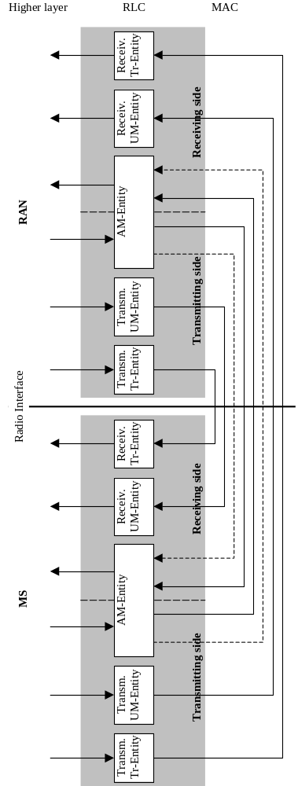

Figure 4-1 Overview model of RLC.

Transparent mode entities
Figure 4- below shows the model of two transparent mode peer entities.
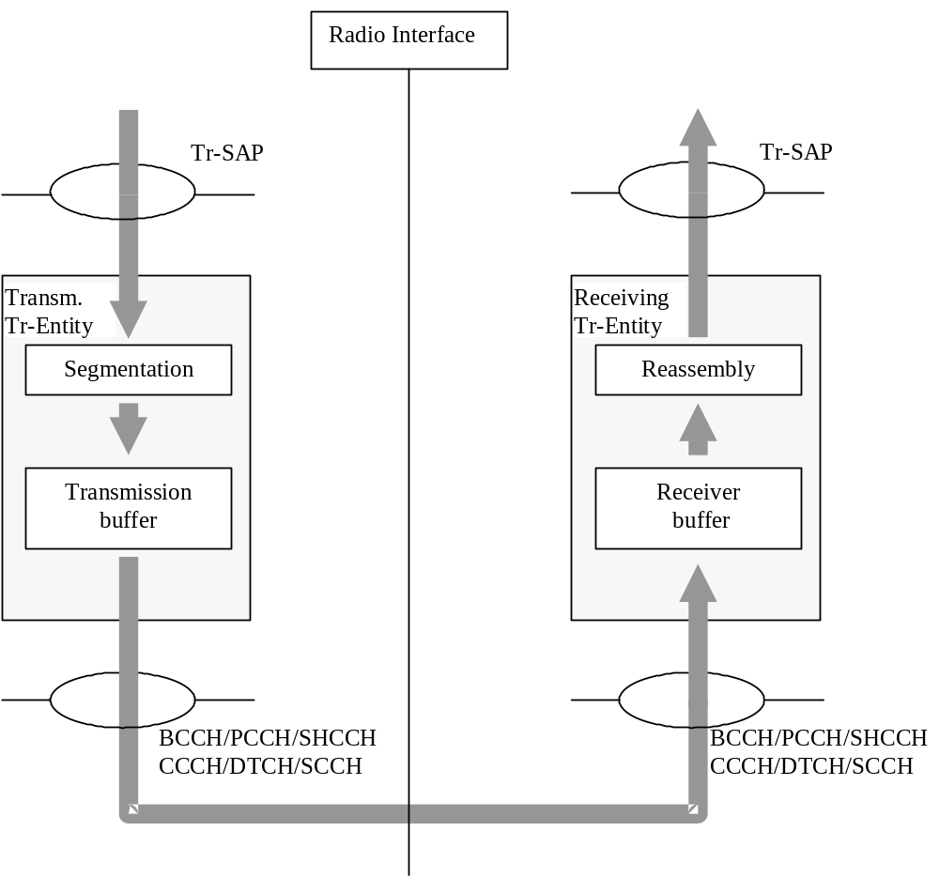
Figure 4-2 Model of two transparent mode peer entities.
The transmitting Tr-entity receives SDUs from the higher layers through the Tr-SAP. RLC might segment the SDUs into appropriate RLC PDUs without adding any overhead. How to perform the segmentation is decided upon when the service is established. RLC delivers the RLC PDUs to MAC through either a BCCH, PCCH ,SCCH , SHCCH or a DTCH. The delivery of RLC PDUs to MAC through CCCH is FFS. Which type of logical channel depends on if the higher layer is located in the control plane (BCCH, PCCH, CCCH,SCCH, SHCCH) or user plane (DTCH).
The Tr-entity receives PDUs through from one of the logical channels from the MAC sublayer. RLC reassembles (if segmentation has been performed) the PDUs into RLC SDUs. How to perform the reassembling is decided upon when the service is established. RLC delivers the RLC SDUs to the higher layer through the Tr-SAP.

Unacknowledged mode entities
Figure 4- below shows the model of two unacknowledged mode peer entities.

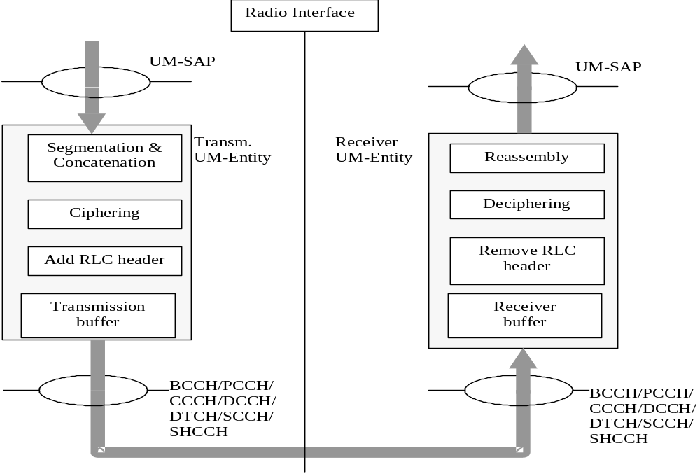
Figure 4-3 Model of two unacknowledged mode peer entities.
The transmitting UM-entity receives SDUs from the higher layers. If the SDU is very large it is segmented into RLC PDUs of appropriate size. The SDU might also be concatenated with other SDUs. RLC adds a header and the PDU is placed in the transmission buffer. RLC delivers the RLC PDUs to MAC through either a DCCH ,a SHCCH (downlink only) or a DTCH. The delivery of RLC PDU’s to MAC through BCCH, PCCH, CCCH,SCCH is for FFS. Which type of logical channel depends on if the higher layer is located in the control plane (BCCH, PCCH, CCCH, DCCH,SCCH) or user plane (DTCH).

The receiving UM-entity receives PDUs through one of the logical channels from the MAC sublayer. RLC removes header from the PDUs and reassembles the PDUs (if segmentation has been performed) into RLC SDUs. After that the SDUs are delivered to the higher layer.

Acknowledged mode entity
Figure 4- below shows the model of an acknowledged mode entity.

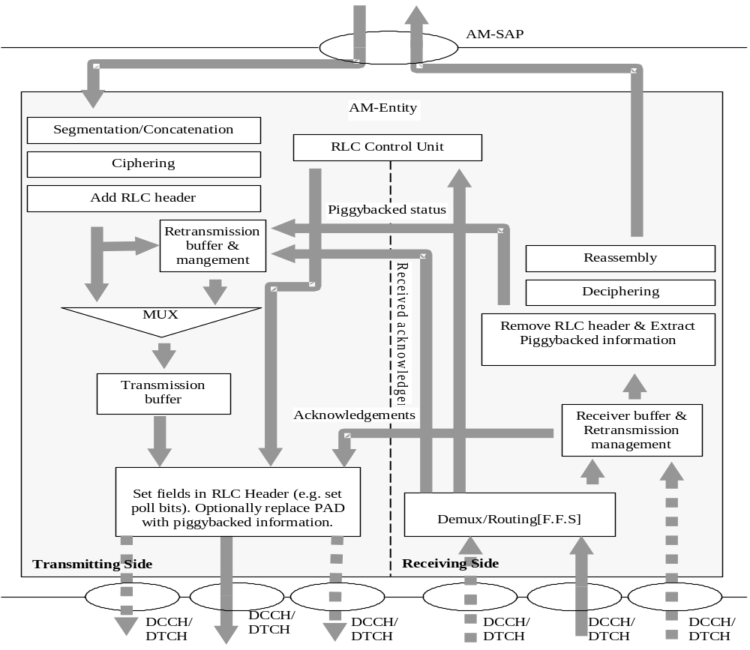Figure 4-4 Model of a acknowledged mode entity.

The transmitting side of the AM-entity receives SDUs from the higher layers. The SDUs are segmented and/or concatenated to PUs of fixed length. PU length is a semi-static value that is decided in bearer setup and can only be changed through bearer reconfiguration by RRC.
For purposes of RLC buffering and retransmission handling, the operation is the same as if there would be one PU per PDU. For concatenation or padding purposes, bits of information on the length and extension, are inserted into the beginning of the last PU where data from an SDU is included. If several SDU:s fit into one PU, they are concatenated and the appropriate length indicators are inserted into the beginning of the PU. After that the PU:s are placed in the retransmission buffer and the transmission buffer. RLC PDU is constructed from PU buffers.
The MUX then decides which PDUs and when the PDUs are delivered to MAC, e.g. it could be useful to send RLC control PDUs on one logical channel and data PDUs on another logical channel. The PDUs are delivered via a function that completes the RLC-PDU header and potentially replaces padding with piggybacked status information. This includes setting the poll bit, compressing subsequent PUs into one RLC-PDU or setting up the extended RLC-PDU header (PUs not in sequence) where applicable.
When Piggybacking mechanism is applied the padding is replaced by control information, in order to increase the transmission efficiency and making possible a faster message exchange between the peer to peer RLC entities. The piggybacked control information is not saved in any retransmission buffer. The piggybacked control information is contained in the piggybacked STATUS PDU which is in turn included into the AMD-PDU. The piggybacked STATUS PDUs will be of variable size in order to match with the amount of free space in the AMD PDU.
The dashed lines illustrate the case where AMD PDUs and control PDUs are transmitted on separate logical channels. The retransmission buffer also receives acknowledgements from the receiving side, which are used to indicate retransmissions of PUs and when to delete a PU from the retransmission buffer.
The Receiving Side of the AM-entity receives PDUs through one of the logical channels from the MAC sublayer. The RLC-PDUs are expanded into separate PUs and potential piggybacked status information are extracted. The PUs are placed in the receiver buffer until a complete SDU has been received. The receiver buffer requests retransmissions of PUs by sending negative acknowledgements to the peer entity. After that the headers are removed from the PDUs and the PDUs are reassembled into a SDU. Finally the SDU is delivered to the higher layer.
The receiving side also receives acknowledgements from the peer entity. The acknowledgements are passed to the retransmission buffer on the transmitting side.

Functions
The following functions are supported by RLC.For a detailed description of the following functions see [9]
- Connection Control;
- Segmentation and reassembly;
- Header compression;
- Concatenation;
- Padding;
- Transfer of user data;
- Error correction;
- In-sequence delivery of higher layer PDUs;
- Duplicate Detection;
- Flow control;
- Sequence number check (Unacknowledged data transfer mode);
- Protocol error detection and recovery.
- Ciphering;/Deciphering.
The following potential function(s) are regarded as further study items (FFS):
- Suspend/resume function

Services provided to upper layers
This section describes the different services provided by RLC to higher layers. It also includes mapping of functions to different services.For a detailed description of the following functions see [9]

- RLC connection establishment/release;
Transparent data transfer Service
The following functions are needed to support transparent data transfer:
- Segmentation and reassembly
- Transfer of user data;
- Unacknowledged data transfer Service
Following functions are needed to support unacknowledged data transfer:
- Segmentation and reassembly
- Concatenation
- Padding
- Transfer of user data
- Ciphering/Deciphering
- Sequence number check;
- Acknowledged data transfer Service
Following functions are needed to support acknowledged data transfer:
- Segmentation and reassembly
- Concatenation
- Padding
- Transfer of user data
- Error correction
- In-sequence delivery of higher layer PDUs
- Duplicate detection
- Flow Control
- Protocol error detection and recovery
- Ciphering/Deciphering;
- QoS setting;
- Notification of unrecoverable errors.
- Multicast delivery of higher layer messages. (FFS)

Mapping of services/functions onto logical channels
The following tables show the applicability of services and functions to the logical channels in UL/DL and UE/RAN. A ‘+’ in a column denotes that the service/function is applicable for the logical channel in question whereas a ‘-‘ denotes that the service/function is not applicable.
Table 6-1: RLC modes and functions in UE uplink side
Service | Functions | CCCH | SHCCH | DCCH | DTCH
Transparent  Service | Applicability | + | + | - | +
Transparent  Service | Segmentation | - | - | - | +
Transparent  Service | Transfer of use data | + | + | - | +
Unacknowledged  Service | Applicability | FFS | - | + | +
Unacknowledged  Service | Segmentation | - | - | + | +
Unacknowledged  Service | Concatenation | - | - | + | +
Unacknowledged  Service | Padding | - | + | + | +
Unacknowledged  Service | Transfer of use data | - | - | + | +
Unacknowledged  Service | Ciphering | - | - | + | +
Acknowledged  Service | Applicability | - | - | + | +
Acknowledged  Service | Segmentation | - | - | + | +
Acknowledged  Service | Concatenation | - | - | + | +
Acknowledged  Service | Padding | - | - | + | +
Acknowledged  Service | Transfer of use data | - | - | + | +
Acknowledged  Service | Flow Control | - | - | + | +
Acknowledged  Service | Error Correction | - | - | + | +
Acknowledged  Service | Protocol error correction & recovery | - | - | + | +
Acknowledged  Service | Ciphering | - | - | + | +

Table 6-2: RLC modes and functions in UE downlink side
Service | Functions | SCCH | BCCH | PCCH | SHCCH | CCCH | DCCH | DTCH | CTCH
Transparent  Service | Applicability | + | + | + | + | + | - | + | +
Transparent  Service | Reassembly | + | + | + | - | - | - | + | -
Unacknowledged  Service | Applicability | + | FFS | FFS | + | FFS | + | + | +
Unacknowledged  Service | Reassembly | + | + | + | + | - | + | + | +
Unacknowledged  Service | Deciphering | - | - | - | - | - | + | + | FFS
Unacknowledged  Service | Sequence number  check | - | - | - | + | - | + | + | +
Acknowledged  Service | Applicability | - | - | - | - | - | + | + | -
Acknowledged  Service | Reassembly | - | - | - | - | - | + | + | -
Acknowledged  Service | Error correction | - | - | - | - | - | + | + | -
Acknowledged  Service | Flow Control | - | - | - | - | - | + | + | -
Acknowledged  Service | In sequence delivery | - | - | - | - | - | + | + | -
Acknowledged  Service | Duplicate detection | - | - | - | - | - | + | + | -
Acknowledged  Service | Protocol error correction & recovery | - | - | - | - | - | + | + | -
Acknowledged  Service | Deciphering | - | - | - | - | - | + | + | -

Table 6-3: RLC modes and functions in RAN downlink side
Service | Functions | SCCH | BCCH | PCCH | CCCH | SHCCH | DCCH | DTCH | CTCH
Transparent  Service | Applicability | + | + | + | + | + | - | + | +
Transparent  Service | Segmentation | + | + | + | - | - | - | + | -
Transparent  Service | Transfer of use data | + | + | + | + | + | - | + | +
Unacknowledged  Service | Applicability | + | FFS | FFS | FFS | + | + | + | +
Unacknowledged  Service | Segmentation | + | + | + | - | + | + | + | +
Unacknowledged  Service | Concatenation | + | + | + | - | + | + | + | +
Unacknowledged  Service | Padding | + | - | - | + | + | + | + | +
Unacknowledged  Service | Ciphering | - | - | - | - | - | + | + | FFS
Acknowledged  Service | Applicability | - | - | - | - | - | + | + | -
Acknowledged  Service | Segmentation | - | - | - | - | - | + | + | -
Acknowledged  Service | Concatenation | - | - | - | - | - | + | + | -
Acknowledged  Service | Padding | - | - | - | - | - | + | + | -
Acknowledged  Service | Transfer of use data | - | - | - | - | - | + | + | -
Acknowledged  Service | Flow Control | - | - | - | - | - | + | + | -
Acknowledged  Service | Error Correction | - | - | - | - | - | + | + | -
Acknowledged  Service | Protocol error correction & recovery | - | - | - | - | - | + | + | -
Acknowledged  Service | Ciphering | - | - | - | - | - | + | + | -

Table 6-4: RLC modes and functions in RAN uplink side
Service | Functions | CCCH | SHCCH | DCCH | DTCH
Transparent  Service | Applicability | + | + | - | +
Transparent  Service | Reassembly | - | - | - | +
Unacknowledged  Service | Applicability | FFS | - | + | +
Unacknowledged  Service | Reassembly | - | - | + | +
Unacknowledged  Service | Deciphering | - | - | + | +
Unacknowledged  Service | Sequence number  check | - | - | + | +
Acknowledged  Service | Applicability | - | - | + | +
Acknowledged  Service | Reassembly | - | - | + | +
Acknowledged  Service | Error correction | - | - | + | +
Acknowledged  Service | Flow Control | - | - | + | +
Acknowledged  Service | In sequence delivery | - | - | + | +
Acknowledged  Service | Duplicate detection | - | - | + | +
Acknowledged  Service | Protocol error correction & recovery | - | - | + | +
Acknowledged  Service | Deciphering | - | - | + | +

Services expected from MAC
For a detailed description of the following functions see [9].
- Data transfer;

Elements for layer-to-layer communication

Primitives between RLC and higher layers
The primitives between RLC and upper layers are shown in Table 8-5.

Table 8-5 : Primitives between RLC and upper layers
Generic Name | Parameter
 | Req. | Ind. | Resp. | Conf.
RLC-AM-DATA | Data, CFN, MUI | Data | Not Defined | MUI
RLC-UM-DATA | Data, QR (ffs) | Data | Not Defined | Not Defined
RLC-TR-DATA | Data | Data,TD | Not Defined | Not Defined
CRLC-CONFIG | E/R | Not Defined | Not Defined | Not Defined
CRLC-STATUS | Not Defined | EVC | Not Defined | Not Defined

Each Primitive is defined as follows:
RLC-AM-DATA-Req./Ind/Conf.
- RLC-AM-DATA-Req is used by higher layers to request transmission of a higher layer PDU in acknowledged mode.
- RLC-AM-DATA-Ind is used by RLC to deliver to higher layers RLC SDUs, that have been transmitted in acknowledged mode.
- RLC-AM-DATA-Conf is used by RLC to confirm to higher layers the transmission of a RLC SDU.

RLC-UM-DATA-Req./Ind.
- RLC-UM-DATA-Req is used by higher layers to request transmission of a higher layer PDU in unacknowledged mode.
- RLC-UM-DATA-Ind is used by RLC to deliver to higher layers RLC SDUs, that have been transmitted in unacknowledged mode.

RLC-TR-DATA-Req./Ind

- RLC-TR-DATA-Req is used by higher layers to request transmission of a higher layer PDU in transparent mode.
- RLC-TR-DATA-Ind is used by RLC to deliver to higher layers RLC SDUs, that have been transmitted in transparent mode.
CRLC-CONFIG-Req
It is used for establishment and release of point-to-point connection between the same level user entities.
This primitive is used by RRC to establish, release or reconfigure the RLC.
CRLC-STATUS-Ind
It is used by the RLC to send status information to RRC.

Following parameters are used in the primitives:
- The parameter Data is the RLC SDU that is mapped onto the Data field in RLC PDUs. The Data parameter may be divided over several RLC PDUs.In case of a RLC-AM-DATA or a RLC-UM-DATA primitive the length of the Data parameter shall be octet alligned.
- The parameter Confirmation request (CNF) indicates whether the RLC needs to confirm the correct transmission of the RLC SDU.
- The parameter Message Unit Identifier (MUI) is an identity of the RLC SDU, which is used to indicate which RLC SDU that is confirmed with the RLC-AM-DATA conf. primitive.
- The parameter RX Timing Deviation (TD) contains the RX Timing Deviation measurement of the physical layer for the resources carrying the Data. It is an optional parameter for RLC-TR-DATA-Ind.
- The parameter E/R indicates whether RLC should enter or exit the data transfer ready state.
- The parameter Event Code (EVC) indicates the reason for the CRLC-STATUS-ind (i.e unrecoverable errors such as data link layer loss or recoverable status events such as reset, etc.).

Elements for peer-to-peer communication

Protocol data units

Data PDUs

- TrD PDU (Transparent Mode Data PDU)
The TrD PDU is used to convey RLC SDU data without adding any RLC overhead. The TrD PDU is used by RLC when it is in transparent mode.
- UMD PDU (Unacknowledged Mode Data PDU)
The UMD PDU is used to convey sequentially numbered PDUs containing RLC SDU data. It is used by the RLC when using the unacknowledged data transfer.
- AMD PDU (Acknowledged Mode Data PDU)
The AMD PDU is used to convey sequentially numbered PUs containing RLC SDU data. The AMD PDU is used by RLC when it is in acknowledged mode.

Control PDUs
- STATUS PDU and Piggybacked STATUS PDU
The STATUS PDU and Piggybacked STATUS PDU are used
- by the receiving entity to inform the transmitting entity about missing PUs at the receving entity either upon detection of a missing PU or as a response to a polling request from the transmitting entity.
- by the receiving entity to inform the transmitting entity about the size of the allowed transmission window;
- and by the transmitting entity to request the receiving entity to move the receiving window.
- RESET (Reset)
- The RESET PDU is used in acknowledged mode to reset all protocol states, protocol timers and some of the protocol variables of the peer RLC entity in order to synchronize the two peer entities. The protocol variables that are not reset are the following: VT(S), VT(A), VT(MS), VR(R), VR(H) and VR(MR). The SN of the last received/transmitted PU is included in the RESET message.RESET ACK (Reset Acknowledge)
The RESET ACK PDU is an acknowledgement to the RESET PDU. The SN of the last received/transmitted PU is included in the RESET ACK message. Upon reception of RESET ACK the transmission continues from RLC-PDU with sequence number SN(latest received)+1.

Table 9-6: RLC PDU names and descriptions
Functionality | PDU name | Description
Transparent Data transfer | TrD | Transparent mode data
Unacknowledged Data Transfer | UMD | Sequenced unacknowledged mode data
Acknowledged Data Transfer | AMD | Sequenced acknowledged mode data
Acknowledged Data Transfer | STATUS | Solicited or Unsolicited Status Report
Acknowledged Data Transfer | Piggybacked STATUS | Piggybacked Solicited or Unsolicited Status Report
Acknowledged Data Transfer | RESET | Reset Command
Acknowledged Data Transfer | RESET ACK | Reset Acknowledgement

Formats and parameters

Formats
This section specifies the format of the RLC PDUs. The parameters of each PDU are explained in section 9.2.2.

TrD PDU
The TrD PDU transfers user data when RLC is operating in transparent mode. No overhead is added by RLC.

Figure 9-2 TrD PDU

UMD PDU
The UMD PDU transfers user data when RLC is operating in unacknowledged mode.
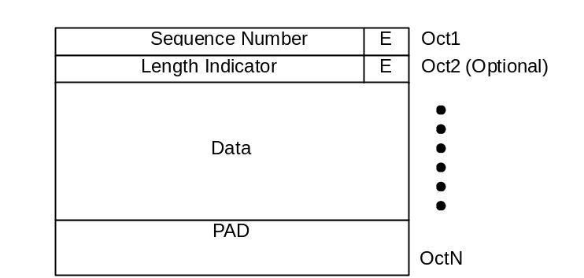
Figure 9-2 UMD PDU

AMD PDU

The AMD PDU transfers user data and piggybacked status information and requests status report by setting Poll bit when RLC is operating in acknowledged mode..
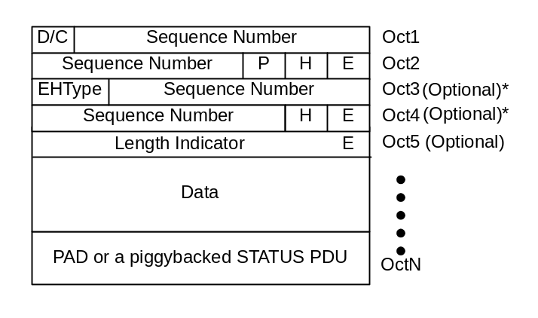
Figure 9-3 AMD PDU
* If the transferred PUs are not in sequence, these optional fields should be presented.The actual number of these fields depend on the number of the PUs in Data field.In this situation the parameter EHType should be set to 00.

STATUS PDU
The STATUS PDU is used to reports the status between two RLC AM entities.Both receiver and transmitter status information may be include in the same STATUS PDU.
The format of the STATUS PDU is given in Figure 9-1 below.

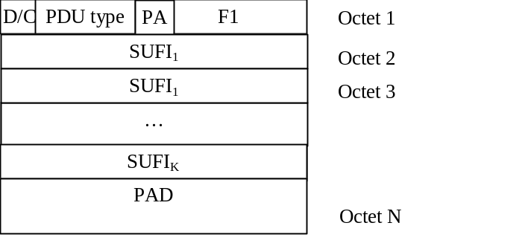

Figure 9-4 Status Information Control PDU (STATUS PDU)
Up to K

Piggybacked STATUS PDU
The format of the piggybacked STATUS PDU is the same as the ordinary STATUS PDU except that the D/C field and the PDU type field is omitted. This PDU can be used to piggyback STATUS PDU in a AMD PDU if the data does not fill the complete AMD PDU
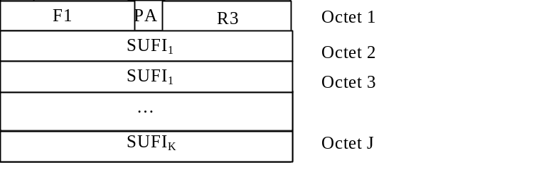
Figure 9-5 Piggybacked STATUS PDU

RESET, RESET ACK PDU
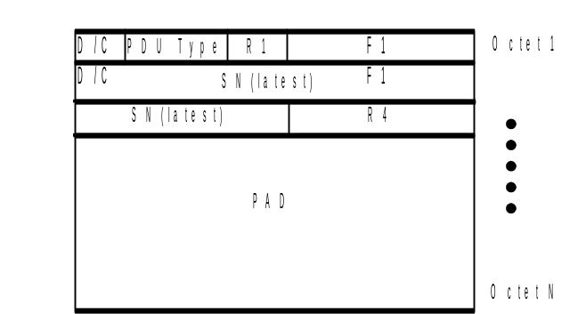

Figure 9-6 RESET, RESET ACK PDU

Parameters
The RLC PDU parameters are defined as follows:

D/Cfield
Length: 1bit
This D/C field indicates the type of an acknowledged mode PDU. It can be either data or control PDU.

Bit | Description
0 | Control PDU
1 | Acknowledged mode data PDU

PDU Type
Length: 2 bits
This PDU Type field togather with the F1 field indicates the type of Control PDU. They are indicated by the special values of sequence number field.

F1
Length: 4 bits
The F1 field together with the PDU Type field indicates the Control PDU type.
If PDU Type is 00, F1 contians the SUFI Type
The following table summarises the use of PDU Type field and F1 field:

Bit (PDU Type) | Bit (F1) | Control PDU Type
00 | SUFI Type | STATUS
01 | - | Reserved
10 | - | Reserved
11 | 0000 | RESET
11 | 0001 | RESET ACK
11 | 0010-1111 | Reserved

Sequence Number (SN)
This field indicates the sequence number of the payload unit. In a normal AMD-PDU the sequence number of the first PU in the PDU is indicated. If the PU:s are not in sequence, a sequence number is indicated separately for each PU in the extended header.

PDU type | Length | Notes
AMD PDU | 12 bits | Used for retransmission and reassembly
UMD PDU | 7 bits | Used for reassembly

Padding (PAD)
Padding may have any value and the receiving entity shall disregard it

Polling bit (P)
Length: 1bit
This field is used to request a status report (STATUS PDU) from the receiver RLC.

Bit | Description
0 | -
1 | Request a status report

Extension bit (E)
Length: 1bit
This bit indicates whether the next octet will be header information (LI) or data.

Bit | Description
0 | The next octet is data
1 | The next octet is header information (LI)

Reserved – 1bit (R1)
Length: 1bit
This field is used to achieve octet alignment and for this purpose it is coded as 0. Other functions of it are left for future releases.

Reserved – 3 bits (R3)
Length: 3 bits
This field is used to achieve octet alignment and for this purpose it is coded as 000. Other functions of it are left for future releases.

Reserved – 4 bits (R4)
Length: 4 bits
This field is used to achieve octet alignment and for this purpose it is coded as 0000. Other functions of it are left for future releases.

Header Extension flag (H)
Length: 1bit
Setting the header extension flag to 1 indicates the first two bits of the next octet contain the Extended Header type field (EHType field) in the AMD-PDU.

Extended Header Type (EHType)
Length: 2 bits
This two-bit field indicates the format of the extended header.

Value | Description
00 | Extension consists of SN+H+E for additional PU sequence numbers
01 | Reserved for future use
10 | Reserved for future use
11 | Reserved for future use

EHType 00:
This value is used when additional sequence numbers are needed to indicate PU:s that are not sequential within a PDU. The n^{th} sequence number in the extended header indicates the sequence number of the (n+1)^{th} PU in the PDU. The space to accommodate the extended header is provided by transmitting one PU less than normally with the same AMD PDU size. The decision to use this EHType is made by the transmitting RLC. The format is described in Figure 9-7.
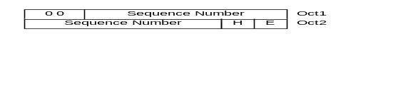

Figure 9-7 AMD PDU Extended Header with EHType = 00

Length Indicator (LI)
Length: 7bit
This field is optional and is used if concatenation, padding or piggybacking takes place inthe PDU. It indicates the end of the last segment of a SDU.The values that are reserved for special purposes are listed in the table below:

Bit | Description
0000000 | The previous RLC PDU was exactly filled with the last segment of a RLC SDU.
1111110 | The rest part of the RLC PDU includes a piggybacked STATUS PDU.
1111111 | The rest part of the RLC PDU is padding.

Data
RLC SDUs or parts of RLC SDUs are mapped to this field.

Poll Answer (PA)
Length: 1bit
This PA (Poll Answer) field indicates whether the status report is the answer to a poll or not
Bit | Description
0 | The status report is not the answer to a polling request
1 | The status report is the answer to a polling request

SUFI (SUper-FIeld)
Length: variable number of bits
The SUFI includes three fields: type information (type of super-field, e.g. list, bitmap or acknowledgement), length information (providing the length of a variable length field within the following value field) and a value. Figure 9-88 shows the structure of the super-field. The size of the type field is non-zero but the size of the other fields may be zero.
Type
Length
Value
Figure 9-8 The Structure of a Super-Field
The length of the type field is 4 bits and it may have any of following values.

Bit | Description
0000 | No More Data (NO_MORE)
0001 | Window Size (WINDOW)
0010 | Acknowledgement (ACK)
0011 | List (LIST)
0100 | Bitmap (BITMAP)
0101 | Relative list (Rlist)
0110 | Move Receiving Window (MRW)
0111 | List 2 (LIST_2)
1000 | Bitmap 2 (BITMAP_2)
1000-1111 | Reserved for future super-field types

The length sub-field gives the length of the variable size part of the following value sub-field and the length of it depends on the super-field type.The value sub-field includes the value of the super-field, e.g. the bitmap in case of a BITMAP super-field, and the length is given by the length or the type sub-field.

The No More Data super-field
The ‘No More Data’ super-field indicates the end of the data part of a STATUS PDU and is shown in Figure 9- below.

Type=NO_MORE
Figure 9-9 NO_MORE field in a STATUS PDU

The Acknowledgement super-field

The ‘Acknowledgement’ super-field consists of a type identifier field (ACK) and a sequence number (LSN) as shown in Figure 9-30 below. The acknowledgement super-field is also indicating the end of the data part of a STATUS PDU. Thus, no ‘NO_MORE’ super-field is needed in the STATUS PDU when the ‘ACK’ super-field is present.

Type = ACK
LSN
Figure 9-30 The ACK fields in a STATUS PDU

LSN
Length: 12 bits
Acknowledges the reception of all PUs with sequence numbers < LSN (Last Sequence Number) that are not indicated to be erroneous in earlier parts of the STATUS PDU. The LSN should not be set to a value ≥ VR(H). This means that if the LSN is set to a different value than VR(R) all erroneous PUs must be included in the same STATUS PDU and VT(A) will be updated according to the first error indicated in the STATUS PDU.

The Window Size super-field
The ‘Window Size’ super-field consists of a type identifier (WINDOW) and a window size number (WSN) as shown in Figure 9-41 below. The receiver is always allowed to change the window size during a connection.

Type = WINDOW
WSN
Figure 9-41 The WINDOW fields in a STATUS PDU

WSN
Length: 12 bits
The allowed window size to be used by the transmitter. The range of the window size is [0, 2¹²-1]. The Window_Size parameter is set equal to WSN.

The List SUFI
The List Super-Field consists of a type identifier field (LIST), a list length field (LENGTH) and a list of LENGTH number of pairs as shown in Figure 9-5below:

Type = LIST
LENGTH
SN₁
L₁
SN₂
L₂
…
SN_{LENGTH}
L_{LENGTH}
Figure 9-52 The List fields in a STATUS PDU for a list
LENGTH
Length: 4 bits The number of (SN_{i} , L_{i})-pairs in the super-field of type LIST.
SN_{i}
Length: 12 bits
Sequence number of PU which was not correctly received.
L_{i}
Length: 4 bits
Number of consecutive PUs not correctly received following PU with sequence number SN_{i}.

The Bitmap SUFI
The Bitmap Super-Field consists of a type identifier field (BITMAP), a bitmap length field (LENGTH), a first sequence number (FSN) and a bitmap as shown in Figure 9-63 below:

Type = BITMAP
LENGTH
FSN
Bitmap
Figure 9-63 The Bitmap fields in a STATUS PDU.

LENGTH
Length: 4 bits
The size of the bitmap in octets (maximum bitmap size: 2⁴*8=128 bits).

FSN
Length: 12 bits
The sequence number for the first bit in the bitmap.

Bitmap
Length: variable number of octets given by the LENGTH field
Status of the SNs in the interval [FSN, FSN + LENGTH*8 - 1] indicated in the bitmap where each position can have two different values (0 and 1) with the following meaning (bit_position∈[0,LENGTH*8 - 1]):
1: SN = (FSN + bit_position) has been correctly received
0: SN = (FSN + bit_position) has not been correctly received

The Relative List super-field
The Relative List super-field consists of a type identifier field (RLIST), a list length field (LENGTH), the first sequence number (FSN) and a list of LENGTH number of codewords (CW) as shown in Figure 9-7 below.

Type = RLIST
LENGTH
FSN
CW₁
CW₂
…
CW_{LENGTH}
Figure 9-74 The RList fields in a STATUS PDU
LENGTH
Length: 4 bits
The number of codewords (CW) in the super-field of type RLIST.

FSN
Length: 12 bits
The sequence number for the first erroneous PU in the RLIST.

CW
Length: 4 bits
The CW is interpreted as follows:

XXX 0 Next 3 bits of a number are XXX, the number continues in the next CW.
XXX 1 The number is terminated, the most significant bits are XXX.
By default, the CWs represent a distance from the previous indicated erroneous PU.
One special value of CW is defined:
000 1 ‘Error burst indicator’
The error burst indicator means that the next CW:s will represent the number of subsequent erroneous PU:s (not counting the already indicated error position). After the number of errors in a burst is terminated with XXX 1, the next codeword will again by default be the least significant bits (LSB) of the distance to the next error.

SUFI for a Move Receiving Window
The ‘Move Receiving Window’ super-field is used to request the RLC receiver to move its receiving window, as a result of a SDU discard in the RLC transmitter. The format is given in the figure below.

Type = MRW
SN
Figure 9-85 The MRW fields in a STATUS PDU
Type
Length: 3 bits
Bit combination 110 can be used for Move Receiving Window (MRW) command
SN
Length: 12 bits
Requests the RLC receiver to discard all PUs with sequence number < SN, and to move the receiving window accordingly.

The List 2 super-field
The List 2 super-field consists of a type identifier field (LIST_2), and the sequence numbers of the first and of the last PU not correctly received (FSN and LSN respectively), as shown in Figure 9-1.7 below. This super-field is conveniently used instead of List super-field if the number of consecutive lost PUs is greater than 16.

Type = LIST_2
FSN
LSN
Figure 9-96 The List 2 fields in a STATUS PDU
FSN
Length: 12 bits
Sequence number of the first PU not correctly received.
LSN
Length: 12 bits
Sequence number of last PU not correctly received.

The Bitmap 2 super-field
The Bitmap 2 Super-Field consists of a type identifier field (BITMAP_2), a bitmap length field (LENGTH), a first sequence number (FSN) and a bitmap as shown in Figure 9-18 below. This super-field is conveniently used instead of Bitmap super-field if the number of bits to be represented in the bitmap is not a multiple of 8.

Type = BITMAP_2
LENGTH
FSN
Bitmap
Figure 9-107 The Bitmap 2 fields in a STATUS PDU.

LENGTH
Length: 8 bits
The size of the bitmap in octets is ceiling (LENGTH/8) octets where the bitmap represent status of only LENGTH amount of PUs(maximum bitmap size: 2⁸= 256 bits).

FSN
Length: 12 bits
The sequence number for the first bit in the bitmap.

Bitmap
Length: Variable number of octets given by the LENGTH field.
Status of the SNs in the interval [FSN, FSN + LENGTH - 1] indicated in the bitmap where each position can have two different values (0 and 1) with the following meaning (bit_position∈[0,LENGTH - 1]):
1: SN = (FSN + bit_position) has been correctly received
0: SN = (FSN + bit_position) has not been correctly received

Protocol states

State model for transparent mode entities
Figure 9- illustrates the state model for transparent mode RLC entities (both transmitting and receiving). A transparent mode entity can be in one of following states.

Null State
In the null state the RLC entity does not exist and therefore it is not possible to transfer any data through it.
Upon reception of an CRLC-CONFIG-Req from higher layer the RLC entity is created and transparent data transfer ready state is entered.

Transparent Data Transfer Ready State
In the transparent data transfer ready, transparent mode data can be exchanged between the entities. Upon reception of an CRLC-CONFIG-Req from higher layer the RLC entity is terminated and the null state is entered.
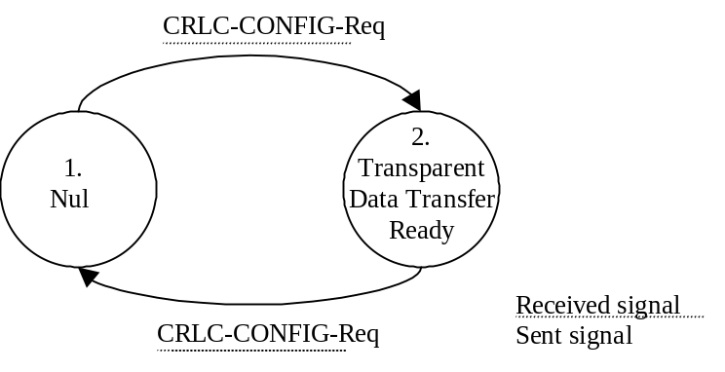
Figure 9-18 The state model for transparent mode entities.

State model for unacknowledged mode entities
Figure 9-11illustrates the state model for unacknowledged mode RLC entities. An unacknowledged mode entity can be in one of following states.

Null State
In the null state the RLC entity does not exist and therefore it is not possible to transfer any data through it.
Upon reception of an CRLC-CONFIG-Req from higher layer the RLC entity is created and unacknowledged data transfer ready state is entered.

Unacknowledged Data Transfer Ready State
In the unacknowledged data transfer ready, unacknowldged mode data can be exchanged between the entities. Upon reception of an CRLC-CONFIG-Req from higher layer the RLC entity is terminated and the null state is entered.

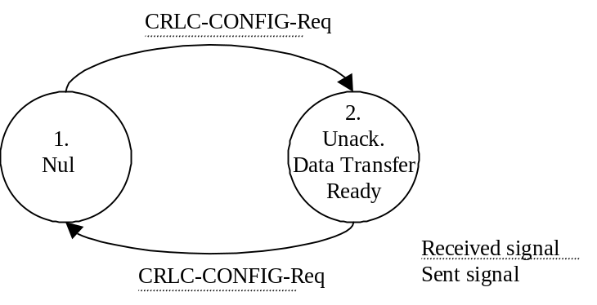
Figure 9-119 The state model for unacknoledged mode entities.

State model for acknowledged mode entities
Figure 9-illustrates the state model for the acknowledged mode RLC entity. An acknowledged mode entity can be in one of following states.

Null State
In the null state the RLC entity does not exist and therefore it is not possible to transfer any data through it.
Upon reception of an CRLC-CONFIG-Req from higher layer the RLC entity is created and acknowledged data transfer ready state is entered.

Acknowledged Data Transfer Ready State
In the acknowledged data transfer ready state, acknowledged mode data can be exchanged between the entities. Upon reception of a CRLC-CONFIG-Req from higher layer the RLC entity is terminated and the null state is entered.
Upon errors in the protocol, the RLC entity sends a RESET PDU to its peer and enters the reset pending state.
Upon reception of a RESET PDU, the RLC entity resets the protocol and responds to the peer entity with a RESET ACK PDU.

Reset Pending State
In the reset pending state the entity waits for a response from its peer entity and no data can be exchanged between the entities. Upon reception of CRLC-CONFIG-Req from higher layer the RLC entity is terminated and the null state is entered.
Upon reception of a RESET ACK PDU, the RLC entity resets the protocol and enters the acknowledged data transfer ready state.

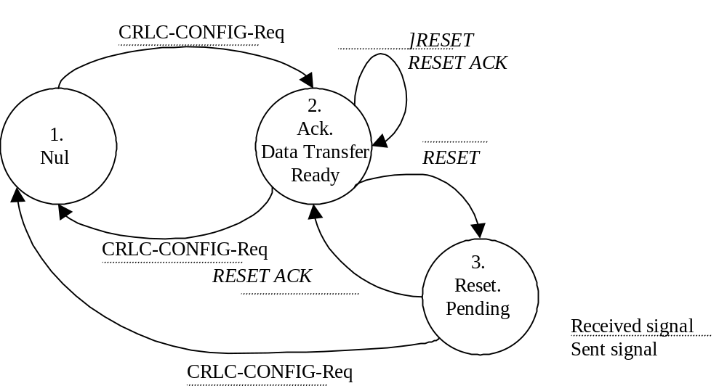

Figure 9-20 The state model for the acknoledged mode entities.

State variables
[All the section shall be reviewed when the protocol is defined]
This sub-clause describes the state variables used in the specification of the peer-to-peer protocol. PUs are sequentially and independently numbered and may have the value 0 through n minus 1 (where n is the modulus of the sequence numbers). The modulus equals 212 for AM and 2⁷ for UM ; The sequence numbers cycle through the entire range, 0 through 212 – 1 for AM and 0 through 2⁷ – 1 for UM. All arithmetic operations on the following state variables and sequence numbers contained in this specification are affected by the modulus: VT(S), VT(A), VT(MS), VR(R), VR(H), and VR(MR). When performing arithmetic comparisons of transmitter variables, VT(A) is assumed to be the base. When performing arithmetic comparisons of receiver variables, VR(R) is assumed to be the base. In addition, the state variables VT(SQ) and VR(SQ) use modulo 2 arithmetic and VT(US) and VT(UR) use modulo 48.
The RLC maintains the following state variables at the transmitter.

  - VT(S) - Send state variable
The sequence number of the next PU to be transmitted for the first time (i.e. excluding retransmission). It is updated after transmission of a PDU which includes not earlier transmitted PU:s.

- VT(A) - Acknowledge state variable
The sequence number of the next in-sequence PU expected to be acknowledged, which forms the lower edge of the window of acceptable acknowledgments. VT(A) is updated based on receipt of a STATUS PDU including an ACK super-field.
- VT(DAT)
This state variable counts the number of times a PU has been transmitted. There is one VT(DAT) for each PU and it is incremented each time the PU is transmitted.

- VT(MS) - Maximum Send state variable
The sequence number of the first PU not allowed by the peer receiver [i.e. the receiver will allow up to VT(MS) – 1], VT(MS) = VT(A) + Window_Size + 1. This value represents the upper edge of the transmit window. The transmitter shall not transmit a new PU if VT(S) = VT(MS). VT(MS) is updated based on receipt of a STATUS PDU.

- VT(US) – UM data state variable
This state variable gives the sequence number of the next UMD PDU to be transmitted. It is updated each time a UMD PDU is transmitted .
- VT(PU)
This state variable is used when the poll every Poll_PU PU function is used. It is incremented with 1 for each PU that is transmitted. It should be incremented for both new and retransmitted PUs. When it reaches Poll_PU a new poll is transmitted and the state variable is set to zero.

- VT(SDU)
This state variable is used when the poll every Poll_SDU SDU function is used. It is incremented with 1 for each SDU that is transmitted. When it reaches Poll_SDU a new poll is transmitted and the state variable is set to zero. The poll bit should be set in the PU that contains the last segment of the SDU.
- VT(RST) - Reset state variable
It is used to count the number of times a RESET PDU is transmitted. VT(RST) is incremented with 1each time a RESET PDU is transmitted. VT(RST) is reset upon the reception of a RESET ACK PDU.

The RLC maintains the following state variables at the receiver:

  - VR(R) - Receive state variable
The sequence number of the next in-sequence PU expected to be received. It is updated upon receipt of the next in-sequence PU.

  - VR(H) - Highest expected state variable
The sequence number of the next highest expected PU. This state variable is updated when a new PU is received with SN≥VR(H).

  - VR(MR) - Maximum acceptable Receive state variable
The sequence number of the first PU not allowed by the receiver [i.e. the receiver will allow up to VR(MR) – 1] VR(MR) = VR(R) + Window_Size. The receiver shall discard PUs with SN= VR(MR), (in one case, such a PU may cause the transmission of an unsolicited STATUS PDU). Updating VR(MR) is implementation dependent, but VR(MR) should not be set to a value < VR(H).

  - VR(US) - Receiver Send Sequence state variable
The sequence number of the latest UMD PDU to be received. It shall set equal to SN + 1 upon reception of a PDU.
  - VR(EP) – Estimated PDU Counter state variable
The number of PUs that should received yet as a consequence of the transmission of the latest STATUS PDU. In acknowledged mode, this state variable is updated at the end of each transmission time interval. It is decremented by the number of PUs that should have been received during the transmission time interval. If VR(EP) is equal to zero, then check if all PUs requested for retransmission in the latest STATUS PDU have been received.

Timers
  - Timer_Poll
This timer is only used when the poll timer trigger is used. It is started when the transmitting side sends a poll to the peer entity. The timer is stopped when receiving a STATUS PDU with the PA bit set. The value of the timer is signalled by RRC.
If the timer expires and no STATUS PDU with the PA bit set has been received the receiver is polled once more (either by the transmission of a PDU which was not yet sent, or by a retransmission) and the timer is restarted.
If a new poll is sent when the timer is running it is restarted.

  - Timer_Poll_Prohibit
This timer is only used when the poll prohibit function is used.It is used to prohibit transmission of polls within a certain period. If polling is taken place during this timer is active, it will be once stopped and set again. This timer will not be stopped by a STATUS PDU. When this timer expires no action is performed. The value of the timer is signalled by RRC.
  - Timer_EPC
This timer is only used when the EPC function is used and it accounts for the roundtrip delay, i.e. the time when the first retransmitted PU should be received after a STATUS has been sent. The timer is started when a STATUS report is transmitted and when it expires EPC can start decrease (see section 9.7.3). The value of the timer is signalled by RRC.
  - Timer_Discard
This timer is used for the SDU discard function. In the transmitter, the timer is activated upon reception of a SDU from higher layer. If the SDU has not been acknowledged when the timer expires, the SDU is discarded and a Move Receiving Window request is sent to the receiver. If the SDU discard function does not use the Move Receiving Window request, the timer is also used in the receiver, where it is activated once a PDU is detected as outstanding, i.e. there is a gap between sequence numbers of received PDUs.The value of the timer is signalled by RRC.
  - Timer_Poll_Periodic
This timer is only used when the timer based polling is used. The timer is started when the RLC entity is created. Each time the timer expires a poll is transmitted and the timer is restarted. The value of the timer is signalled by RRC.

  - Timer_Status_Prohibit
This timer is only used when the STATUS PDU prohibit function is used. It prohibits the receiving side from sending STATUS PDUs. The timer is started when a STATUS PDU is transmitted and no new STATUS PDU can be transmitted before the timer has expired. The value of the timer is signalled by RRC.

  - Timer_Status_Periodic
This timer is only used when timer based STATUS PDU sending is used. The timer is started when the RLC entity is created. Each time the timer expires a STATUS PDU is transmitted and the timer is restarted. The value of the timer is signalled by RRC.

  - Timer_RST
It is used to detect the loss of RESET ACK PDU from the peer RLC entity. This timer is set when the RESET PDU is transmitted. And it will be stopped upon reception of RESET ACK PDU. If it expires, RESET PDU will be retransmitted.

Protocol Parameters

  - MaxDAT
It is the maximum value for the number of retransmissions of a PU. This parameter is an upper limit of counter VT(DAT). When the value of VT(DAT) comes to MaxDAT, error recovery procedure will be performed.
  - Poll_PU
This parameter indicates how often the transmitter should poll the receiver in case of polling every Poll_PU PU. This is an upper limit for the VT(PU) state variable, when VT(PU) reaches Poll_PU a poll is transmitted to the peer entity.
c) Poll_SDU
This parameter indicates how often the transmitter should poll the receiver in case of polling every Poll_SDU SDU. This is an upper limit for the VT(SDU) state variable, when VT(SDU) reaches Poll_SDU a poll is transmitted to the peer entity.
d) Poll_Window
This parameter indicates when the transmitter should poll the receiver in case of performing window based polling. A poll is transmitted when .
e) MaxRST
It is the maximum value for the number of retransmission of RESET PDU. This parameter is an upper limit of counter VT(RST). When the value of VT(RST) comes to MaxRST, the higher layer (RRC) is notified.
f) Window_Size
The maximum allowed transmitter window size.

Specific functions
[The Hybrid ARQ (Type II/III) mechanism scheme is considered for the downlink only; in particular an incremental effort of protocol implementation will be followed. In this way it is possible to estimate the real performance of this scheme but also the impact that the introduction of such a scheme has on the protocol implementation. It is [FFS] if Hybrid ARQ mechanism for the downlink is mandatory for the UE]

Retransmission Scheme

Basic Concept
- Type of retransmission
- Selective retransmission

- Acknowledgement Confirmation
- Receiver Status Report in response to the Transmitter Polling Request;
- Unsolicited status report from the receiver caused by detecting the latest loss of PUs.

- The Retransmission takes place when:
- A Status Report (STATUS (PA=Yes)), transmitted by the Receiver, is received;
- An Unsolicited Status Report (STATUS (PA=No)) is received;
- Retransmission Timer_Poll expires.

- Timing of polling
Basically to confirm acknowledgement every RLC SDU can reduce extra overhead and improve the throughput. But if small RLC SDUs are given continuously, many status reports will be transmitted and it will cause overhead. To solve the problem, this retransmission scheme uses the timer which prohibits excessive polling. This timer only prohibits polling for every RLC SDU.

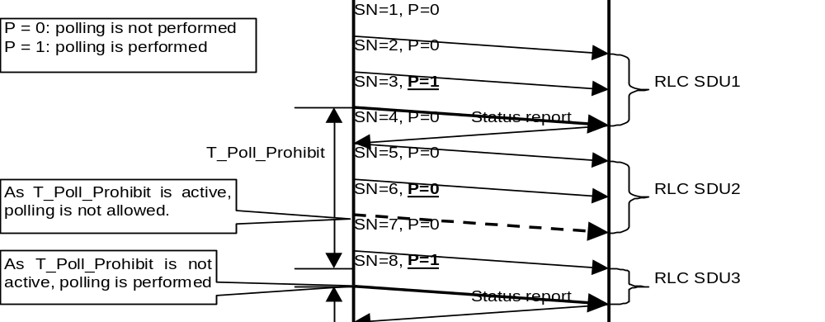

Figure 9-212 Reduction of excessive polling

PDUs used for retransmission
Following PDUs are necessary for this retransmission scheme.
- AMD PDU:
Transfers user data and requests status report by setting Poll bit.
- STATUS PDU:
A STATUS PDU (PA=Yes) reports the status of receiver to transmitter when AMD PDU with status report request is received.The STATUS PDU (PA=No) is transmitted upon detection of an erroneous transmission of one or more data PUs. It is used to inform the transmitter side about missing PUs at the receiver RLC.

Flow of retransmission

Case1) In case STATUS (PA=Yes) is received:
- Polling is performed from the transmitter comply with the polling trigger.
- At this moment, the transmitter sets Timer_STATUS and Timer_Prohibit.
- The receiver transmits STATUS (PA=Yes) which requests retransmission for SN = 2, 3, 4 of PU in response to the polling.
- The transmitter receives the STATUS and stops Timer_STATUS. Then the PUs (SN = 2, 3, 4) requested by the STATUS are retransmitted.
- When the PU whose SN =4 is transmitted, poll bit is set to 1 (polling is performed).
- At this moment, Timer_STATUS is set and Timer_Prohibit is reset.
- When the transmitter receives STATUS (PA=Yes) from the receiver, Timer_STATUS is stopped.

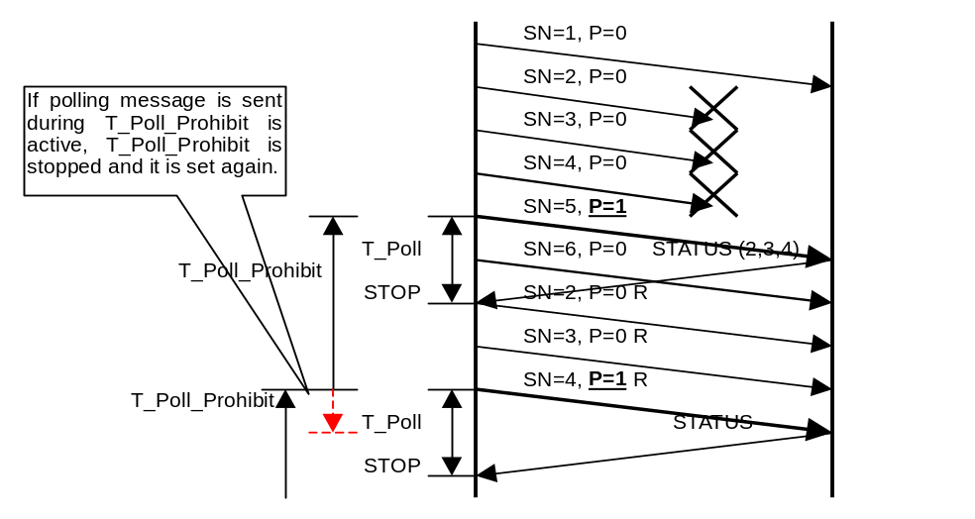

Figure 9-22 Retransmission Scheme Behavior when STATUS is received

- Case2) In case STATUS (PA=No) is received:
- If the receiver detects new loss of PUs, it transmits STATUS (PA=No) which requests retransmission of SN = 2, 3 of PU to the transmitter.
- The transmitter receives the STATUS and retransmits the requested PUs (SN = 2,3).
- In this case polling is not performed when the PU whose SN =3 is retransmitted.
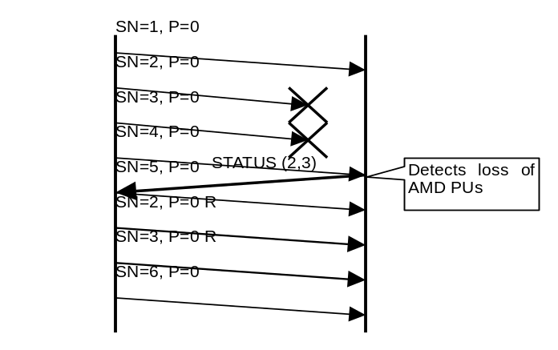
Figure 9-133 Retransmission Scheme Behavior STATUS is received

Case3) In case Timer_STATUS expires:
- If Timer_STATUS expires due to loss of the AMD PDU with polling or STATUS, the transmitter retransmits the AMD PDU with polling.
- At this moment, Timer_STATUS is set and Timer_Prohibit is reset.
- When the transmitter receives STATUS from the receiver, Timer_STATUS is stopped.

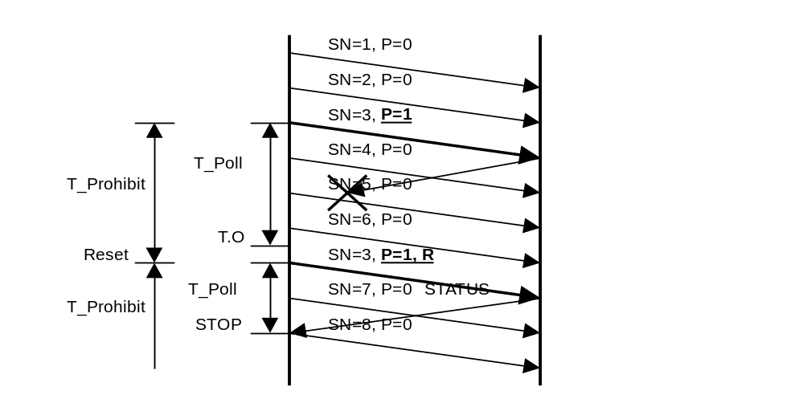
Figure 9-24 Retransmission Scheme Behavior when Timer_STATUS expires
[The Timer T-Prohibit is related only to the UE; there's no need for "T_Prohibit Timer" in the network as it is an implementation aspect. The values for T_Prohibit_Timer are [F.F.S]]

SDU discard function
The SDU discard function allows to discharge RLC PDU from the buffer on the transmitter side, when the transmission of the RLC PDU does not success for a long time.The SDU discard function allows to avoid buffer overflow, in the case of non-transparent transmission mode. There will be several alternative operation modes of the RLC SDU discard function, and which discard function to use will be given by the QoS requirements of the Radio Access Bearer.
The following is a preliminary list of operation modes for the RLC SDU discard function.
Table 9-7. List of criteria’s that control when to perform SDU discard.
Operation mode | Presence
Timer based discard, with explicit signalling | Network controlled
Timer based discard, without explicit signalling | Network controlled
SDU discard after MaxDAT number of retransmissions | Network controlled

Timer based discard, with explicit signalling
This alternative uses Timer_Discard based triggering of SDU discard. This makes the SDU discard function insensitive to variations in the channel rate and provides means for exact definition of maximum delay. However, the SDU loss rate of the connection is increased as SDUs are discarded.
For every SDU received from a higher layer, timer monitoring of the transmission time of the SDU is started. If the transmission time exceeds a predefined value for a SDU in acknowledged mode RLC, this SDU is discarded in the transmitter and a Move Receiving Window (MRW) command is sent to the receiver so that AMD PDUs carrying that SDU are discarded in the receiver and the receiver window is updated accordingly. Note that when the concatenation function is active, PDUs carrying segments of other SDUs that have not timed out shall not be discarded.
The MRW command is defined as a super-field in the RLC STATUS PDU (see section 9.2), and piggy backed to status information of transmissions in the opposite direction. Therefore, SDU discard variants requiring peer-to-peer signalling are only possible for full duplex connections.

Timer based discard, without explicit signalling
This alternative uses the same Timer Discard based trigger for SDU discard as the one described in the section 9.7.2.1. The difference is that this discard method does not use any peer-to-peer signalling. For unacknowledged mode RLC, peer-to-peer signalling is never needed. The SDUs are simply discarded in the transmitter, once the transmission time is exceeded. For acknowledged mode RLC, peer-to-peer signalling can be avoided as long as SDU discard is always performed in the transmitter before it is performed in the receiver. As long as the corresponding SDU is eventually discarded in the receiver too, possible retransmission requests of PDU of discarded SDUs can be ignored by the transmitter. The bigger the time difference is between the triggering of the discard condition at the transmitter and the receiver, the bigger the unnecessary buffering need is at the receiver and the more bandwidth is lost on the reverse link due to unnecessary retransmission requests. On the other hand, forward link bandwidth is saved, as no explicit SDU discard signalling is needed.

SDU discard after MaxDAT number of retransmissions
This alternative uses the number of retransmissions as a trigger for SDU discard, and is therefore only applicable for acknowledged mode RLC. This makes the SDU discard function dependent of the channel rate. Also, this variant of the SDU discard function strives to keep the SDU loss rate constant for the connection, on the cost of a variable delay. SDU discard is triggered at the transmitter, and a MRW command is necessary to convey the discard information to the receiver, like in the timer based discard with explicit signalling.
[The following three options are used in implementing the trigger for SDU discard after MaxDAT number of retransmissions.

Option 1: Negative ACK (NACK) is used in STATUS PDU, i.e., the Bitmap super-field in STATUS PDU. The transmitter retransmits the corrupt AMD PDUs of a SDU when a NACK is received. Upon receiving MaxDAT number of NACK for the same specific SDU, the transmitter simply discards that SDU.

Option 2: The acknowledgement super-field (ACK) is used in the STATUS PDU. The transmitter retransmits the unacknowledged ADM PDUs of a SDU when the STATUS PDUs carrying the same LSN (Last Sequence Number) is received. Upon receiving MaxDAT number of STATUS PDUs carrying the same LSN, the transmitter discards the corresponding SDU.

Option 3: A Timer or Counter is used at the transmitter while the acknowledgement super-field (ACK) or the Bitmap super-field is used in the STATUS PDU. The retransmission of an unacknowledged AMD PDU is triggered by the above-mentioned Timer or Counter. After MaxDAT number of retransmissions, the transmitter discards the SDU containing the unacknowledged AMD PDUs.]

The Estimated PDU Counter
The Estimated PDU Counter is a mechanism used for scheduling the retransmission of status reports in the receiver side. With this mechanism, the receiver will send a new Status PDU in which it requests for PDUs not yet received. The time between two subsequent status report retransmissions is not fixed, but it is controlled by the Estimated PDU Counter (EPC), which adapt this time to the current bit rate, indicated in the TFI, in order to minimise the delay of the status report retransmission.
The EPC is a counter, which is decremented every transmission time interval with the estimated number of PDUs that should have been transmitted during that transmission time interval.When the receiver detects that PDUs are missing it generates and sends a Status PDU to the transmitter and sets the EPC equal to the number of requested PDUs.
A special timer, called EPC timer, controls the maximum time that the EPC needs to wait before it will start counting down. This timer starts immediately after a transmission of a retransmission request from the receiver (Status PDU). The EPC timer typically depends on the roundtrip delay, which consists of the propagation delay, processing time in the transmitter and receiver and the frame structure. This timer can also be implemented as a counter, which counts the number of 10 ms interval could be expected to elapse before the first requested AMD PDU is received.
When the EPC is equal to zero and not all of these requested PDUs have been received correctly, a new Status PDU will be transmitted and the EPC will be reset accordingly. The EPC timer will be started once more.
The EPC is based on the estimation of the number of PDUs that should have been received during a transmission time interval. To estimate this number is easiest done by means of the TFI bits. However, if these bits are lost due to some reason or another, this estimation must be based on something else. A straightforward solution is to base the estimation on the number done in the previous transmission time interval.Only if the rate has changed this estimation is incorrect. Another method of estimating the number of PDUs is based on the maximum allowable rate. The consequence of this is that if the estimation is incorrect, the Status PDU is sent too early. Alternatively, the estimation can be based on the lowest possible transmission rate. In this case, if the estimation is incorrect, the Status PDU will most likely be transmitted too late.

Multiple payload units and header compression
The possibility to include multiple payload units (PU) into one RLC AMD PDU provides a way to support variable bit rate services with lower overhead. The method is to be a part of the service capabilities of a UE capable to support user plane traffic in acknowledged mode.
A semi-static sized payload unit is the smallest unit that can be separately addressed for retransmission. The segmentation and concatenation of SDUs into the RLC transmitter buffer is always performed as if there would be only one PU in each AMD PDU. However one AMD PDU may contain also multiple PUs. The header compression is applied to incorporate several PUs effectively into the AMD PDU and it takes place when the transport block size for the next transmission time interval indicated by MAC can accommodate several PUs. The concept of having multiple PUs in one AMD PDU does not remove the need to still have several transport blocks (RLC PDUs) in the transport block set.
Determination of the configuration of PU and PDU sizes is based on the needed transmission rates. The size of the PU is derived directly from the lowest common block size that can be used to compose all the applicable data rates. To support faster transmission rates more payload units are combined into one AMD PDU with header compression function as long as the size of the PDU reaches the optimum. When higher transmission rates are used, several transport blocks (RLC PDUs) are delivered within one transport block set keeping the amount of PUs the same in one AMD PDU.
The method of multiple PUs in one PDU combined with the header compression is especially useful when the lowest needed transmission bit rate cannot be effectively supported with PDUs optimized for the highest transmission bit rate. Figure 3-1 presents a few examples illustrating the applicability of the method. To illustrate the method,Figure 9-25 shows some examples where the RLC AMD PDU size has been set to 320 bits.
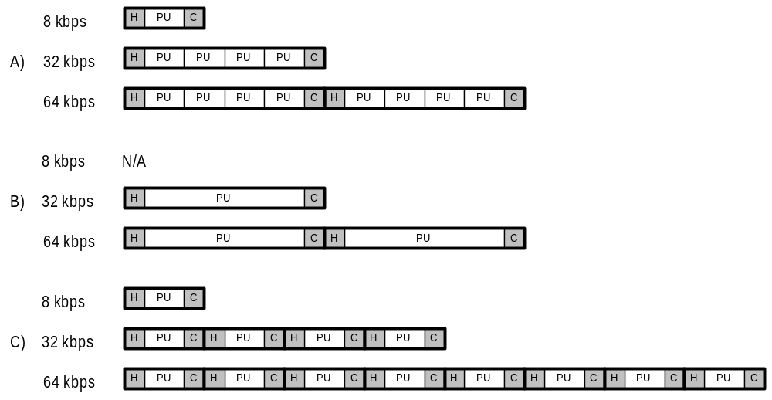
Figure 9-25 Example cases of payload units and PDUs at different transmission rates
Assuming there is a service having a need for variable transmission rate with the maximum above 32 kbps (e.g. 64 kbps) and the minimum of e.g. 8 kbps. With the PU size of 80 bits the flexibility for transmission rates of 8 kbps, 16 kbps or 32 kbps can be achieved by adjusting simply the amount of PUs in one RLC PDU. This also affects on the size of the RLC PDU. While having the optimum sized PDU at 32 kbps, faster transmission rates are constructed by sending several PDUs, each of them containing four PUs (case A).
In case B no data rates below 32 kbps are in the transport format set and the size of the PU is the same as the size of the payload in the RLC PDU. To support transmission bit rates above 32 kbps several PDUs (transport blocks) are sent within one transport block set.
Without the capability to append several PU:s in the PDU the overhead becomes rather high if several transport blocks are sent within one transport block set without header compression at a higher transmission rate (case C).

Credit and peer-to-peer flow control
Credit is granted by the RLC receiver to allow the peer RLC transmitter to transmit new AMD PDUs. The process by which a receiver entity determines credit is not subject to standardization, but is related to the buffer availability and the bandwidth/delay of the connection.
Details of the usage of Crediting is FFS.

Local flow control
RLC events, such as reception of PDUs and external and internal signals, are normally processed in the order in which they occurred. However, events pertaining to the exchange of RLC link status information have priority over data transfer.
An implementation may detect congestion (for example, a long queuing delay) in its lower protocol layers. If so, data transfer should be temporarily suspended in order to give priority to connection control messages. The means by which an RLC entity decides whether or not it is congested depends on the protocol environment, including protocol timer values, and is not subject to standardization.
If a RLC entity detects local congestion (“lower layer busy” in the SDL specification), it can elect to suspend the servicing of RLC-AM-DATA.request, RLC-UM-DATA.request It can also suspend the retransmission of requested AMD PDUs. The data transfer procedures allow this to occur without causing protocol errors.
Therefore, in terms of transmitting PDUs to the peer receiver, all types of PDUs except AMD PDU and UMD PDU are given highest priority. The AMD PDUs and UMD PDUs have equal priority. Among the AMD PDUs, retransmission have priority over new transmission if both types are pending. These priorities are only internal to RLC.

Handling of unknown, unforeseen and erroneous protocol data
A preliminary list of possible error cases is reported below:

a) Inconsistent state variables
If the RLC entity receives a PDU including “erroneous Sequence Number”, state variables between peer entities may be inconsistent. Following shows “erroneous Sequence Number” examples;
- Sequence Number of an AMD PDU is bigger than “Maximum acceptable receive state variable (VR(MR))”,
- Each Sequence Number of missing PU informed by SUFI LIST or BITMAP parameter is not within the value between “Acknowledge state variable(VT(A))” and “Send state variable(VT(S))”, and
- LSN of SUFI ACK is not within the value between “Acknowledge state variable(VT(A))” and “Send state variable(VT(S))”.
b) Repeated failed retransmission over MaxDAT times
It is the case when the number of failed retransmission is over the maximum defined number of retransmission (MaxDAT). The repeated failed retransmission over MaxDat times is an unrecoverable error.

In case of error situations the following actions are foreseen:
- RLC entity should use RESET procedure in case of an unrecoverable error
- RLC entity should discard invalid PDU
- RLC entity should notify upper layer of unrecoverable error occurrence in case of failed retransmission

Elementary procedures

Transparent mode data transfer procedure
The transparent mode data transfer procedure is used for transferring of data between two RLC peer entities, which are operating in transparent mode. The procedure may be initiated either by the UE or by the RAN. Figure 11-14 below illustrates the elementary procedure for transparent mode data transfer.
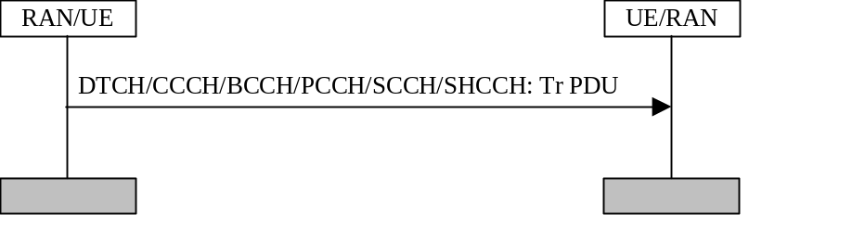
Figure 11-14. Transparent mode data transfer procedure.
The RAN/UE sends one or several Tr PDUs in one transmission time interval on one of the logical channels DTCH, CCCH, BCCH, PCCH SHCCH or SCCH to the UE/RAN. The number of Tr PDUs depends on the rate of the logical channel and the type of logical channel depends on if the RLC entity is located in the user plane (DTCH) or in the control plane (CCCH/BCCH/SHCCH/PCCH,SCCH). The Tr PDU includes a complete or a segment of a higher layer PDU.
[Note: There is no PDU specified for transparent mode data transfer in section 9]

Unacknowledged mode data transfer procedure
The unacknowledged mode data transfer procedure is used for transferring of data between two RLC peer entities, which are operating in unacknowledged mode. The procedure may be initiated either by the UE or by the RAN. 15 below illustrates the elementary procedure for unacknowledged mode data transfer.
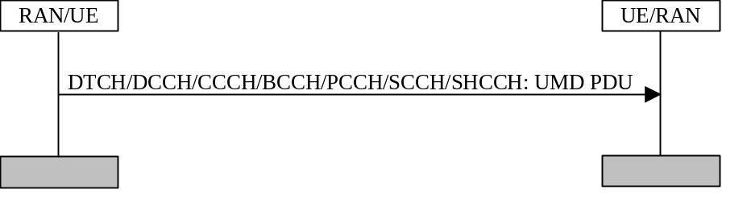
Figure 11-15 Unacknowledged mode data transfer procedure.
The RAN/UE sends one or several UMD PDUs in one transmission time interval on one of the logical channels DTCH, DCCH, CCCH, BCCH, SCCH, SHCCH (downlink only)or PCCH to the RAN/UE. The number of UMD PDUs depends on the rate of the logical channel and the type of logical channel depends on if the RLC entity is located in the user plane (DTCH) or in the control plane (DCCH/CCCH/BCCH/PCCH/SCCH/SHCCH (downlink only)). The UMD PDU includes a segment of one or several higher layer PDUs. It also includes a sequence number and one or several length indicator fields.

Acknowledged mode data transfer procedure
The acknowledged mode data transfer procedure is used for transferring of data between two RLC peer entities, which are operating in acknowledged mode. The procedure may be initiated either by the UE or by the RAN. Figure 11-16 below illustrates the elementary procedure for acknowledged mode data transfer.
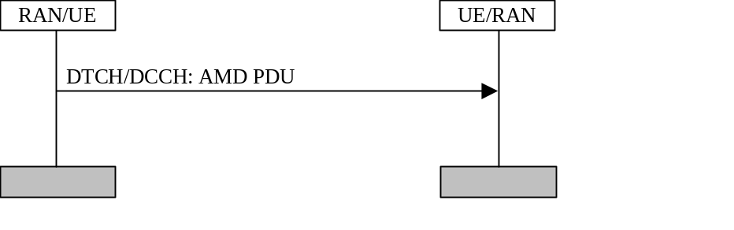
Figure 11-16. Acknowledged mode data transfer procedure.
The RAN/UE sends one or several AMD PDUs in one transmission time interval on either the DTCH or the DCCH logical channel to the receiver UE/RAN. The number of AMD PDUs depends on the rate of the logical channel and the type of logical channel depends on if the RLC entity is located in the user plane (DTCH) or in the control plane (DCCH). The AMD PDU includes a segment of one or several higher layer PDUs. It also includes a D/C field (which indicates that it is data PDU), a sequence number, polling bit, header extension bit and one or several length indicator fields.

RLC reset procedure
The RLC reset procedure is used to reset two RLC peer entities, which are operating in acknowledged mode. It is triggered when a protocol error occurs in RLC and it may be initiated either by the UE or by the RAN. Figure 11-17 below illustrates the elementary procedure for a RLC reset.
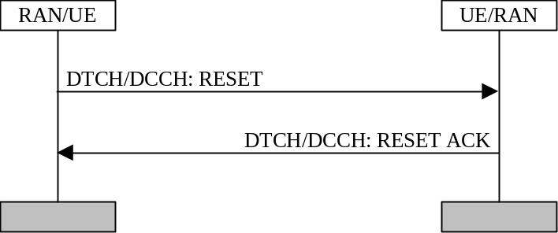
Figure 11-17. RLC reset procedure.
The RAN/UE sends a RESET PDU on a DTCH or a DCCH logical channel to the receiver UE/RAN. The type of logical channel depends on if the RLC entity is located in the user plane (DTCH) or in the control plane (DCCH). The RESET PDU includes the RLC parameters needed to perform the reset.
Upon reception of the RESET PDU, the receiver responds with a RESET ACK PDU.

STATUS PDU transfer procedure
The STATUS PDU transfer procedure is used for transferring of status information between two RLC peer entities, which are operating in acknowledged mode. The procedure may be initiated either by the UE or by the RAN. Figure 11-2 below illustrates the elementary procedure for acknowledged mode data transfer.
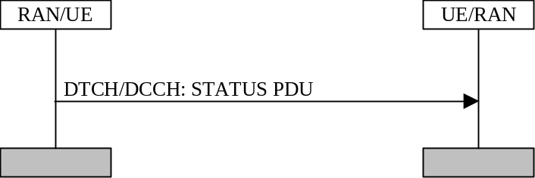
Figure 11-2 STATUS PDU transfer procedure.
The procedure is triggered when e.g. a missing AMD PDU is detected or a poll has been received. The originator RAN/UE sends STATUS PDUs on either the DTCH or the DCCH logical channel to the receiver UE/RAN. The type of logical channel depends on if the RLC entity is located in the user plane (DTCH) or in the control plane (DCCH). The STATUS PDU includes D/C field, PDU type field and information about received data PDUs. This procedure may trigger retransmission of lost PU.

Triggers of the STATUS report procedure
The status report procedure can be triggered in many different ways. Some triggers are always used and some are controlled by the network. RRC signals during setup of the RLC entity which, network controlled triggers that should be used. Table 11-8 below summerizes the triggers of the STATUS report procedure. It is FFS if all triggers have to be supported by the UE.

Table 11-8: List of triggers of the STATUS report procedure.
Trigger | Presence
Reception of poll. | Always
EPC | Network controlled
Detection of missing PU(s). | Network controlled
Timer based. | Network controlled
STATUS PDU prohibit | Network controlled
SDU discard | Network controlled
- Reception of poll
The receiving side sends a STATUS PDU, which at least contains information about received and known missing PUs within the receiving window, to the peer entity upon reception of a poll. The STATUS PDU should be transmitted immediately, except when the EPC or EPC timer is running. This trigger should always be present.
- EPC
The EPC is started when a STATUS PDU, which at least contains information about received and known missing PUs within the receiving window, is transmitted to the peer entity. If not all PUs requested for retransmission have been received before the EPC has expired a new STATUS PDU, which at least contains information about all received and all known missing PUs within the receiving window, is transmitted to the peer entity. A more detailed description of the EPC mechanism is given in section 9.7.3. The network controls if this trigger should be used.
- Detection of missing PU(s)
The receiving side sends a STATUS PDU, which at least contains information about received and known missing PUs within the receiving window, to the peer entity upon detection of missing PU(s). The STATUS PDU should be transmitted immediately. The network controls if this trigger should be used.
- Timer based
The receiving side sends STATUS PDUs , which at least contains information about received and known missing PUs within the receiving window, periodically to the peer entity. The time period is controlled by the timer Timer_Status_Periodic and the value of the timer is signalled by RRC. The network controls if this trigger should be used.
- STATUS PDU prohibit
This is not a trigger, but rather a function that controls how often the receiving side is allowed to send STATUS PDUs to the peer entity. The Timer_Status_Prohibit is started when a STATUS PDU is transmitted to the peer entity. As long as the timer is running the receiving side is not allowed to send a STATUS PDUs to the peer entity. The value of the timer is signalled by RRC. The network controls if this function should be used.
- SDU discard
The transmitting side triggers a STATUS report procedure when performing a SDU discard with explicit signalling. The STATUS PDU should contain at least a MRW SUFI. This trigger is not prohibited by the STATUS PDU prohibit function. The network controls if this trigger should be used.

How to act upon reception of a STATUS PDU
Table 11- below summerizes the different actions of a receiver of a STATUS PDU. These actions should always be performed when receiving a STATUS PDU. RRC signals during setup of the RLC entity, which network controlled actions that should be used.
Table 11-2 List of functions that control how to react upon a STATUS PDU.
Action | Presence
Adjust transmission window. | Always
Retransmit PUs. | Always

- Adjust transmission window
The transmission window should be updated according to the received STATUS PDU.
- Retransmit PUs
This action retransmits the PUs that are requested by the STATUS PDU. The PUs shall be retransmitted immediately and have higher priority than new PUs.

Poll procedure
The poll procedure is used by an acknowledged mode RLC entity for requesting status information from its peer entity. The procedure may be initiated either by the UE or by the RAN.Figure 11-3 below illustrates the elementary procedure for polling.
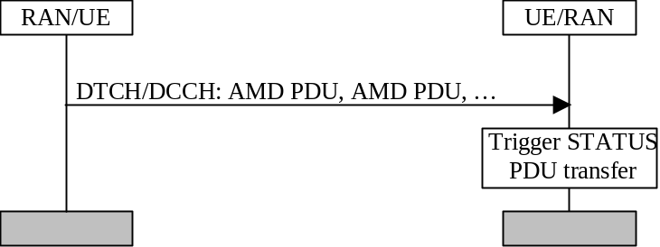
Figure 11-3 Poll procedure.
The procedure is triggered when e.g. the last PU in the transmission buffer is transmitted. The RAN/UE sends one or several AMD PDUs in one transmission time interval on either the DTCH or the DCCH logical channel to the receiver UE/RAN. The number of PDUs depends on the rate of the logical channel and the type of logical channel depends on if the RLC entity is located in the user plane (DTCH) or in the control plane (DCCH). It is FFS if the poll bit is set in all PDUs transmitted in the same transmission time interval.
Upon reception of the polls, the receiver triggers a STATUS PDU transfer procedure.

Triggers of the poll procedure
The poll procedure can be triggered in many different ways. The network controls which triggers that should be used. RRC signals during setup of the RLC entity, which network controlled triggers that should be used. below summerizes the triggers of the STATUS report procedure. It is for FFS if all triggers indicated in Table 11-3 have to be supported by the UE.
Table 11-3 List of triggers of the poll procedure.
Trigger | Presence
Last PU in buffer. | Network controlled
Last PU in retransmission buffer. | Network controlled
Poll timer. | Network controlled
Every Poll_PU PU. | Network controlled
Every Poll_SDU SDU. | Network controlled
Poll_Window% of transmission window. | Network controlled
Timer based. | Network controlled
Poll prohibit | Network controlled

- Last PU in buffer
The transmitting side polls the peer entity for a STATUS PDU, when the last PDU in the transmission buffer is transmitted.
- Last PU in retransmission buffer
The transmitting side polls the peer entity for a STATUS PDU at transmission of the last PU in the retransmission buffer.
- Poll timer
The Timer_Poll is started when a poll is transmitted to the peer entity and if no STATUS PDU has been received before the Timer_Poll expires a new poll is transmitted to the receiver. The value of the timer is signalled by RRC.
- Every Poll_PU PU
The transmitting side polls the peer entity for a STATUS PDU every Poll_PU PU. All PUs should be counted, also retransmitted PUs. The value of Poll_PU is signalled by RRC.
- Every Poll_SDU SDU
The transmitting side polls the peer entity for a STATUS PDU every Poll_SDU SDU. The poll bit should be set in the PU that contains the last segment of the SDU. The value of Poll_SDU is signalled by RRC.
- Poll_Window% of transmission window
The transmitting side polls the peer entity for a STATUS PDU when it has reached Poll_Window % of the transmission window. The value of Poll_Window is signalled by RRC.
- Timer based
The transmitting side polls the peer entity for a STATUS PDU periodically. The time period is controlled by the timer Timer_Poll_Periodic and the value of the timer is signalled by RRC.
- Poll prohibit
This is not a trigger, but rather a function that controls how often the transmitting side is allowed to poll the peer entity. The timer Timer_Poll_Prohibit is started when a poll is transmitted to the peer entity. As long as the timer is running the transmitting side is not allowed to poll the peer entity.The value of Timer_Poll_Prohibit is signalled by RRC.

SDL diagrams

This section contains the SDL diagrams. For Release99, it is meant for informative purposes only.
[All the section shall be reviewed when the protocol is defined;
all the SDL diagrams presented are [FFS]]

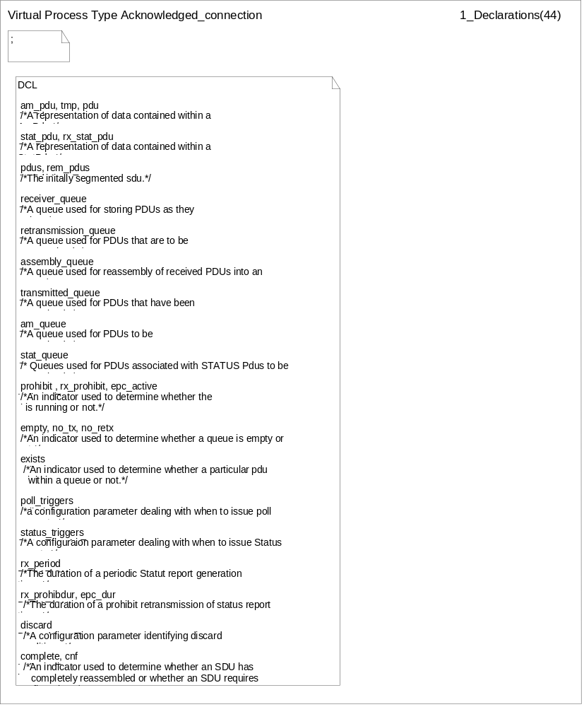
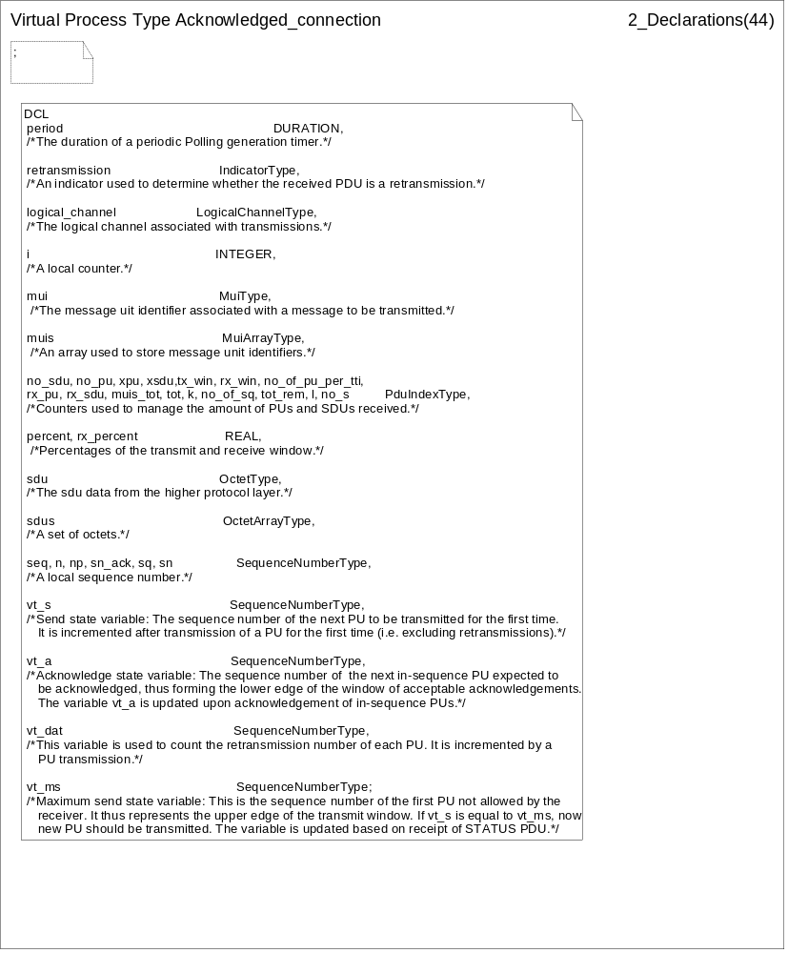
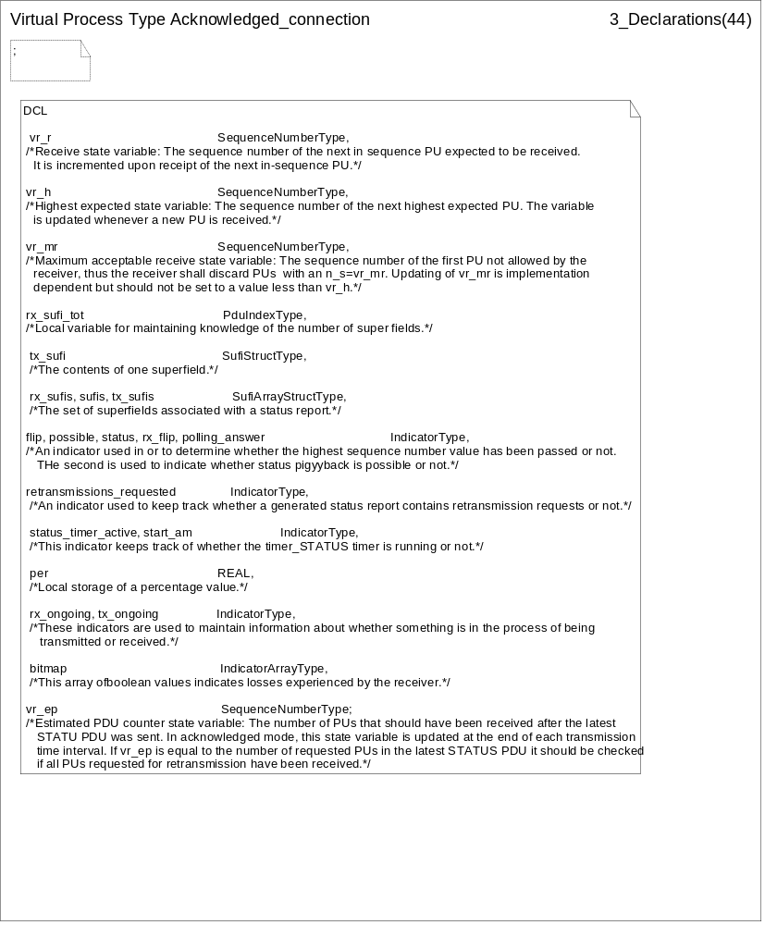
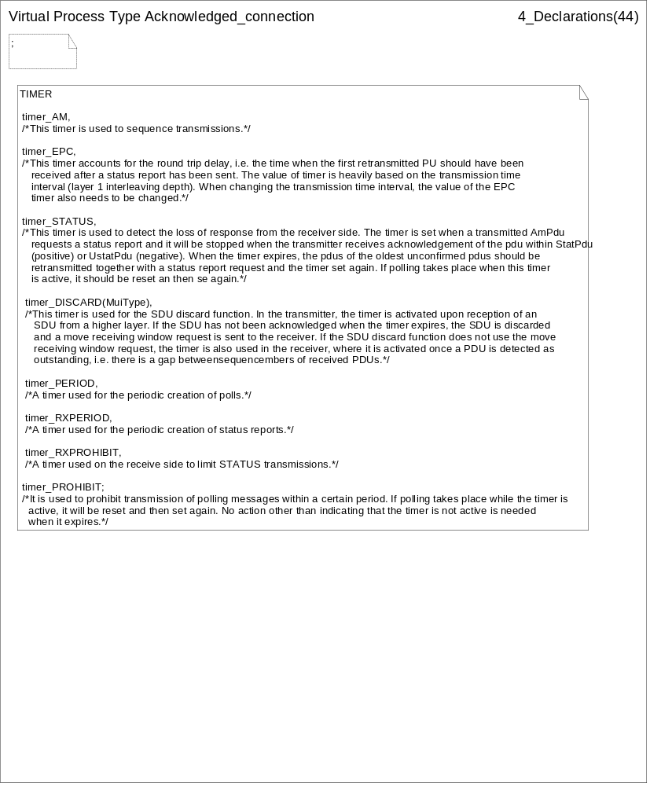
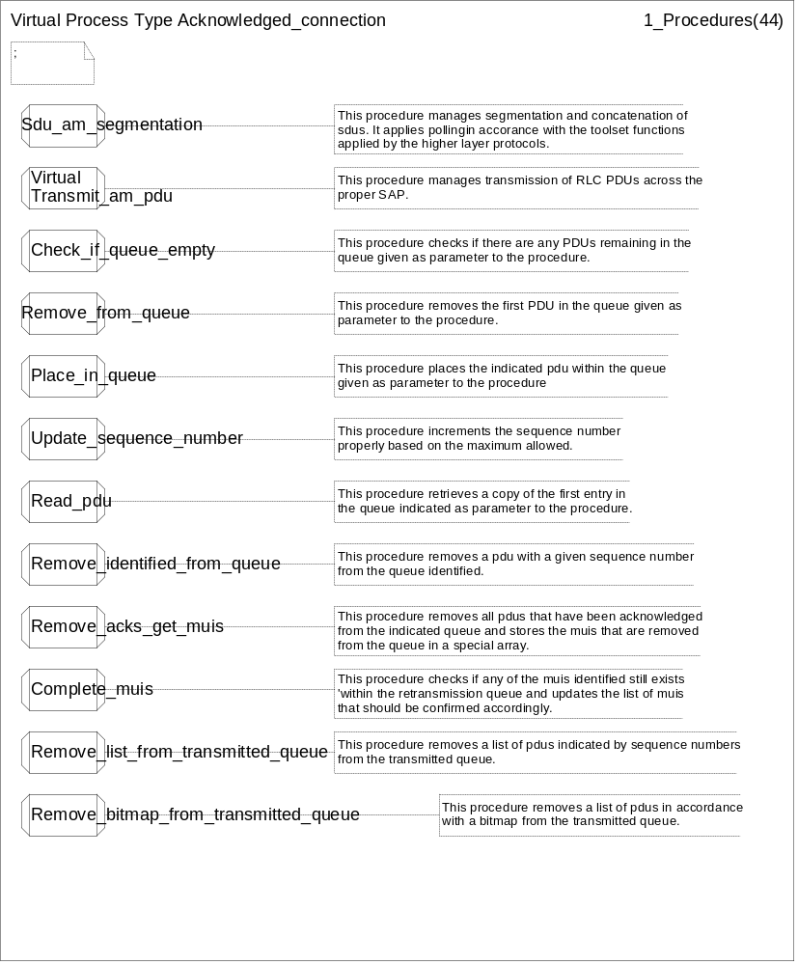
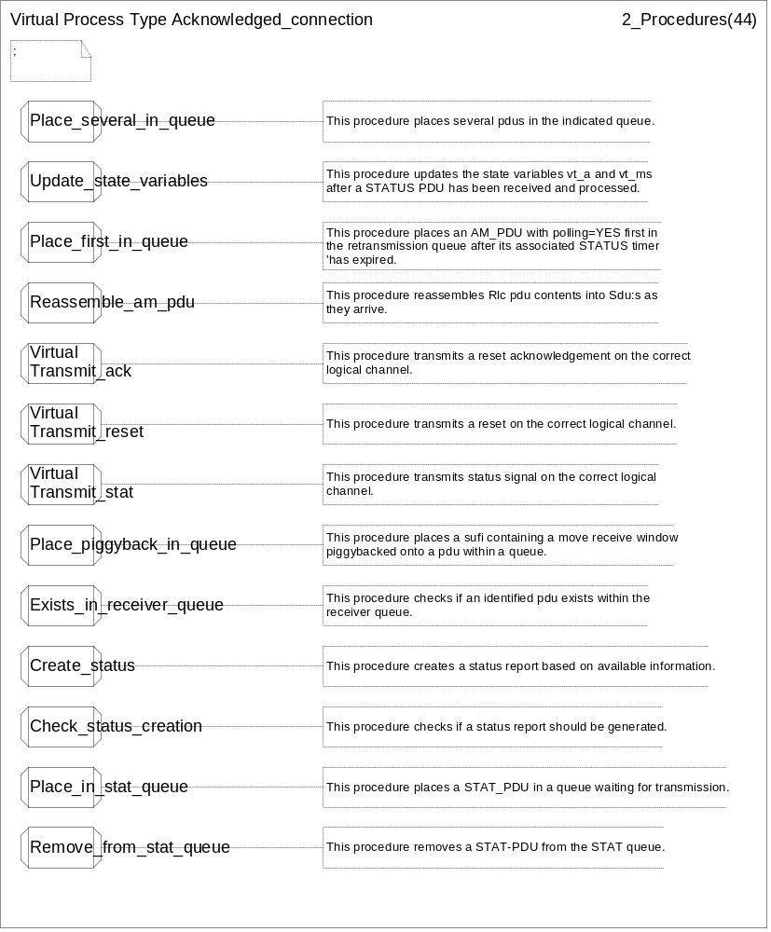
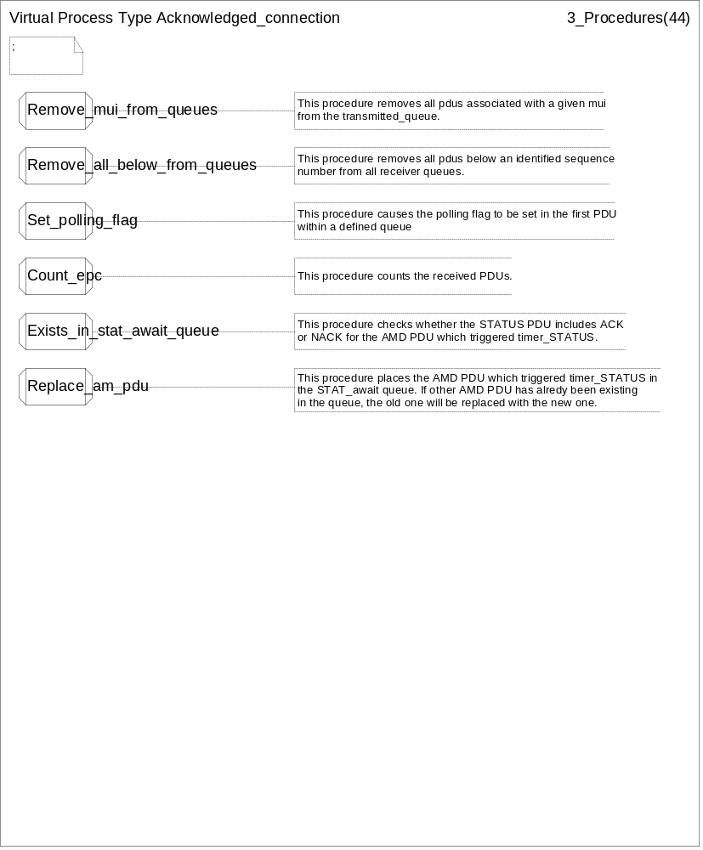
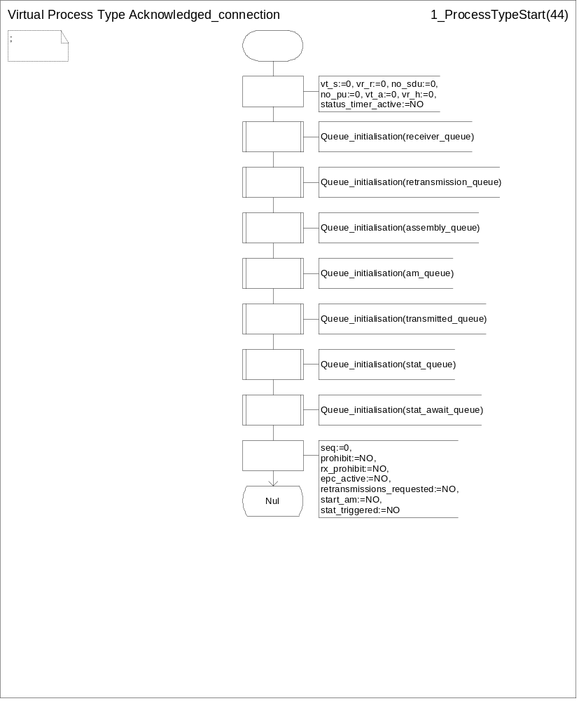
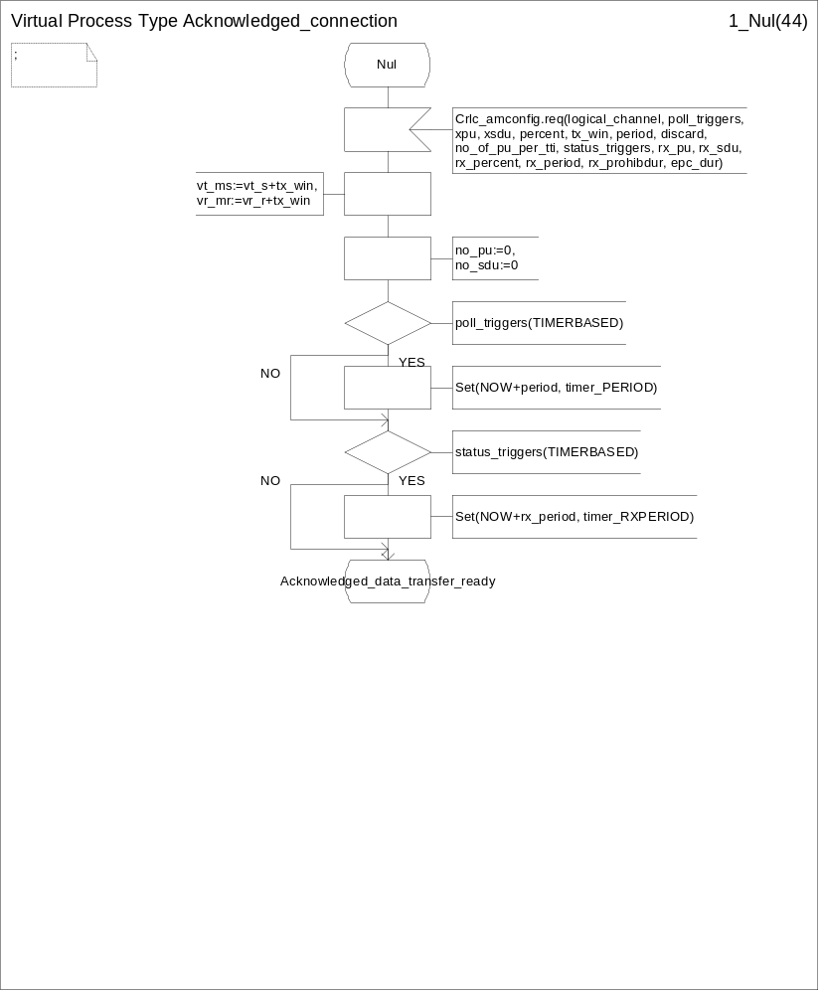
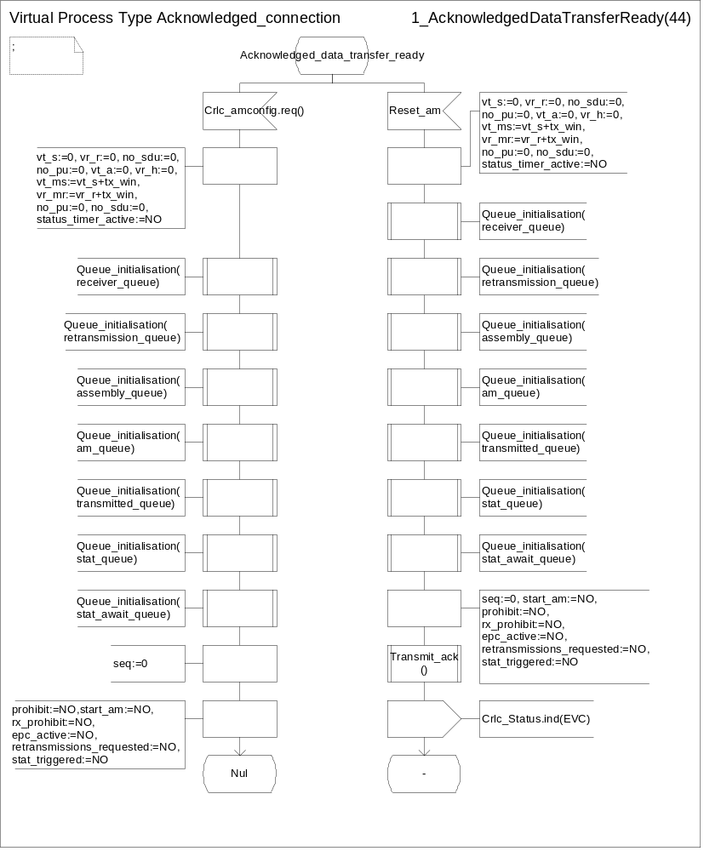
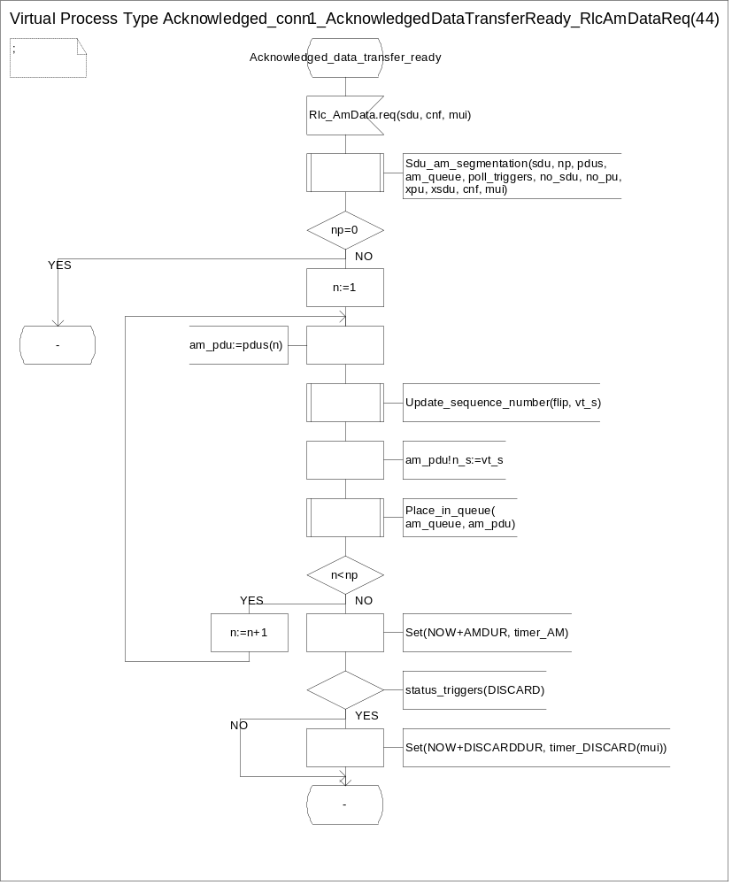
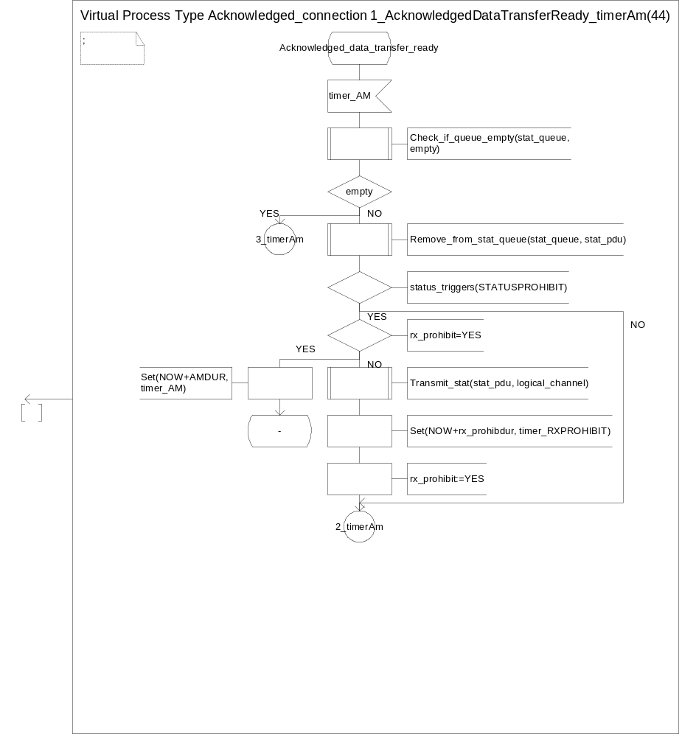
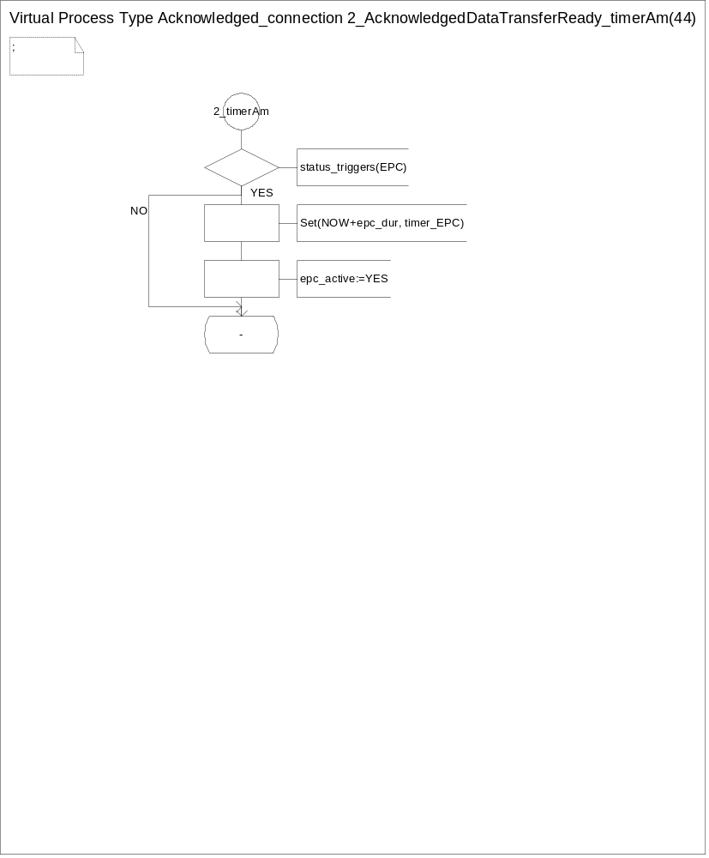
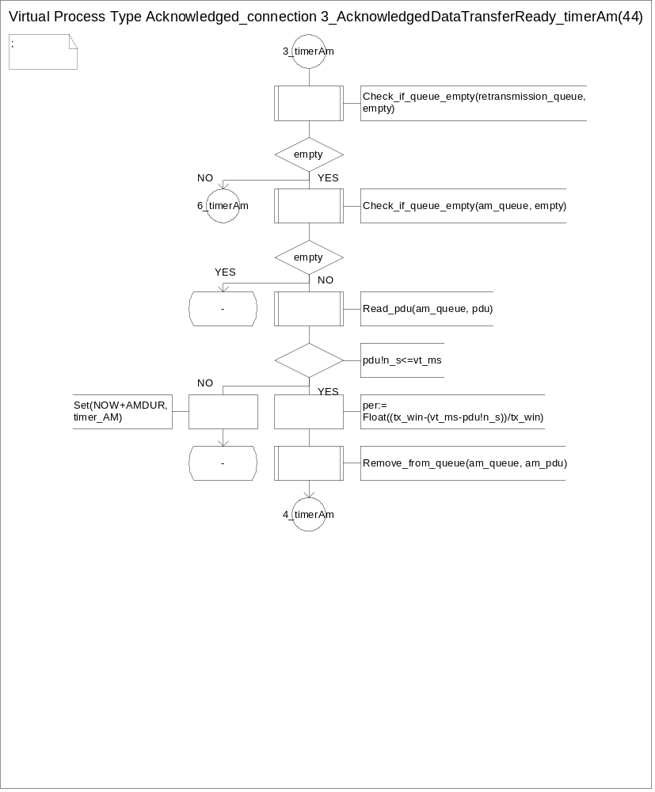
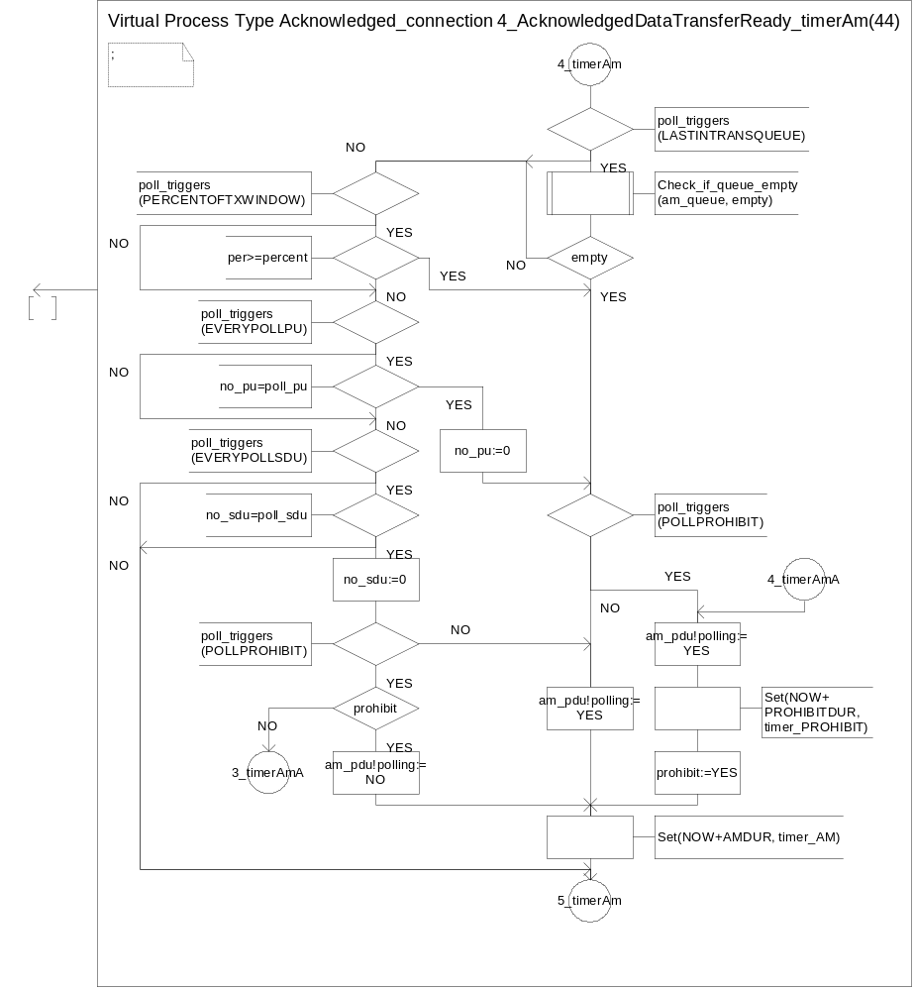
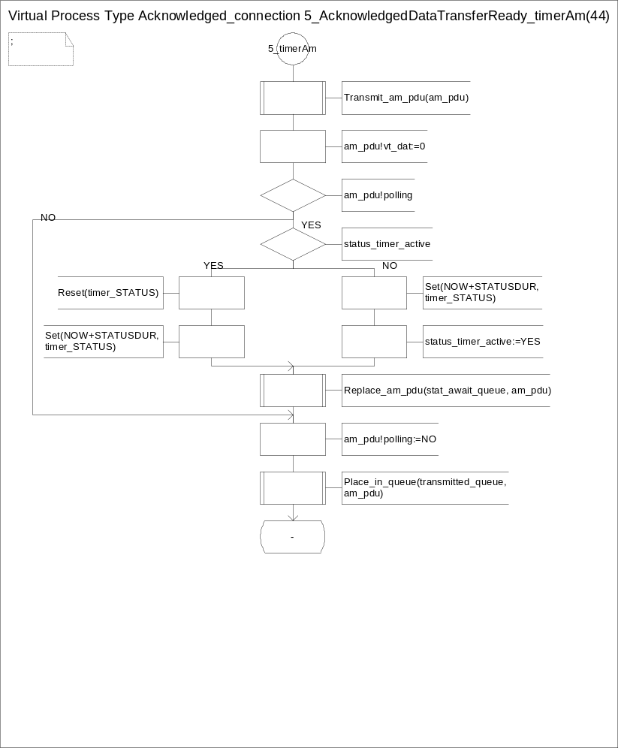
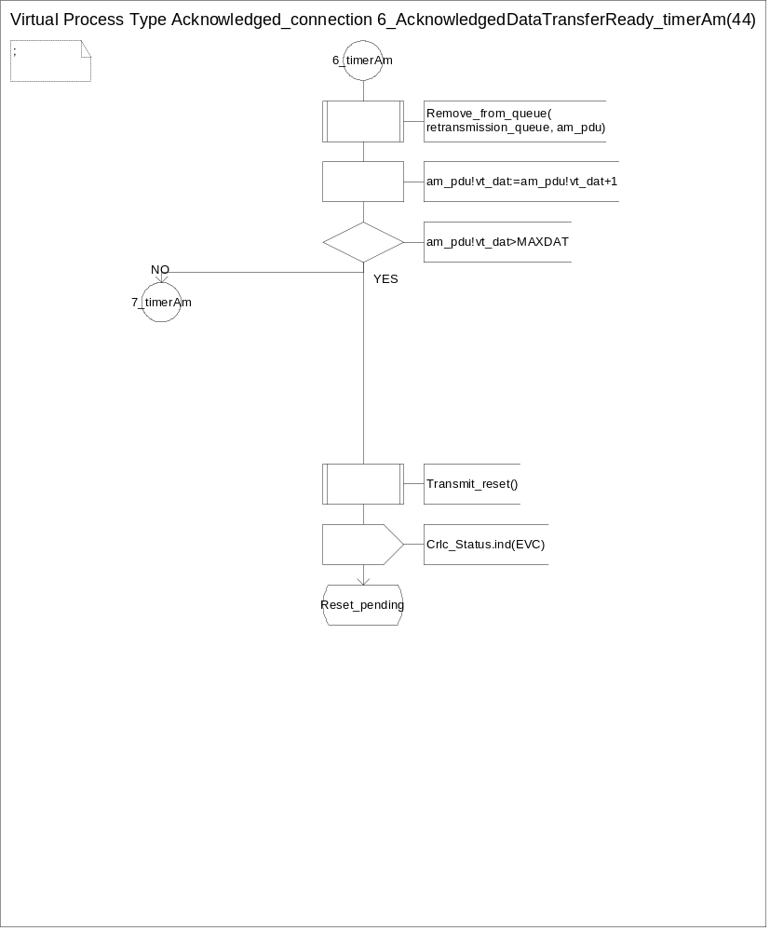
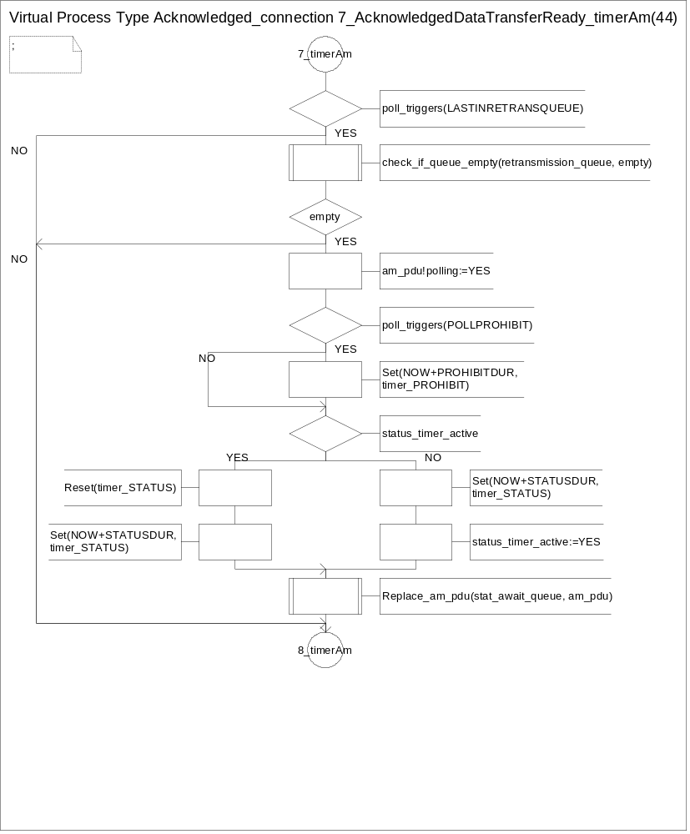
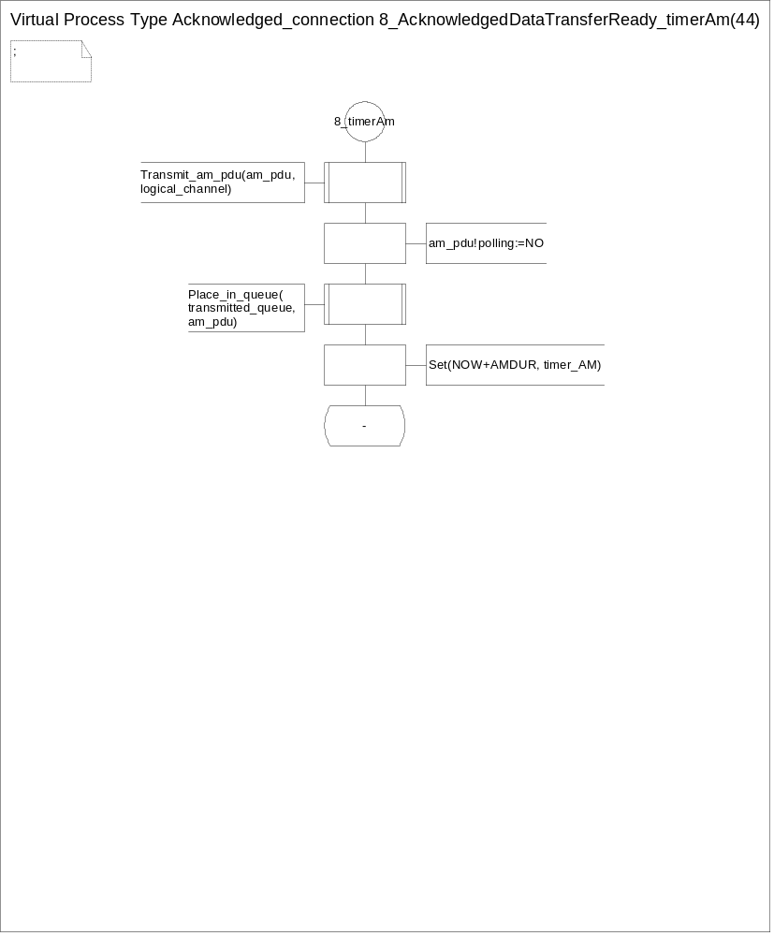
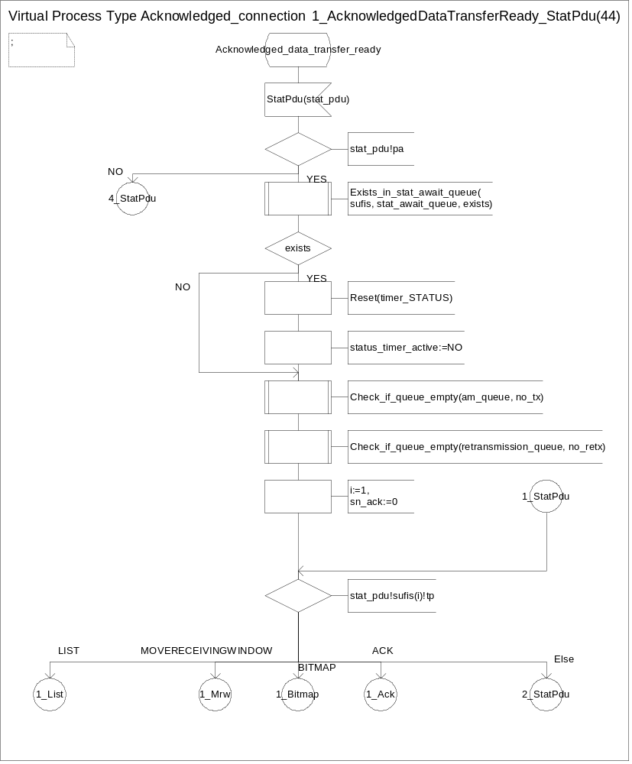
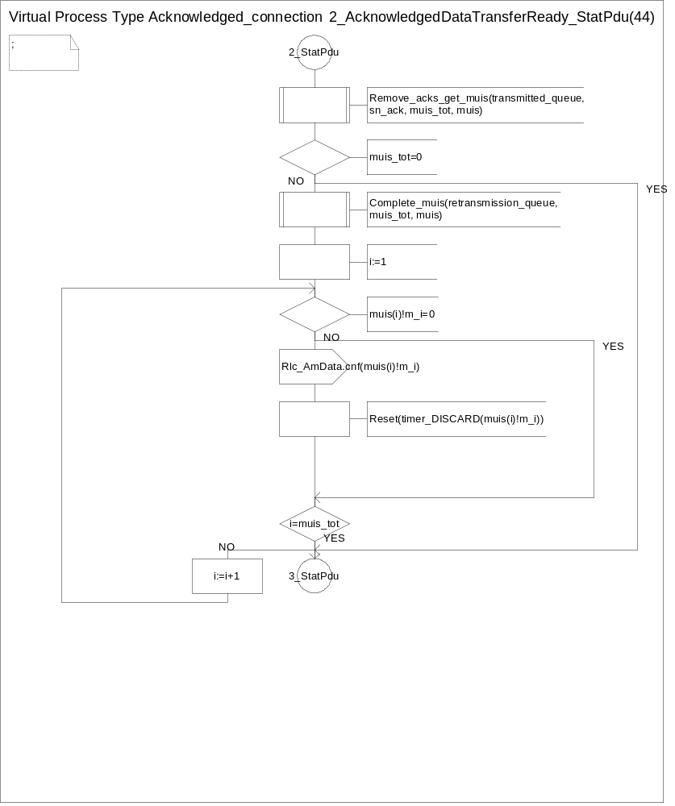
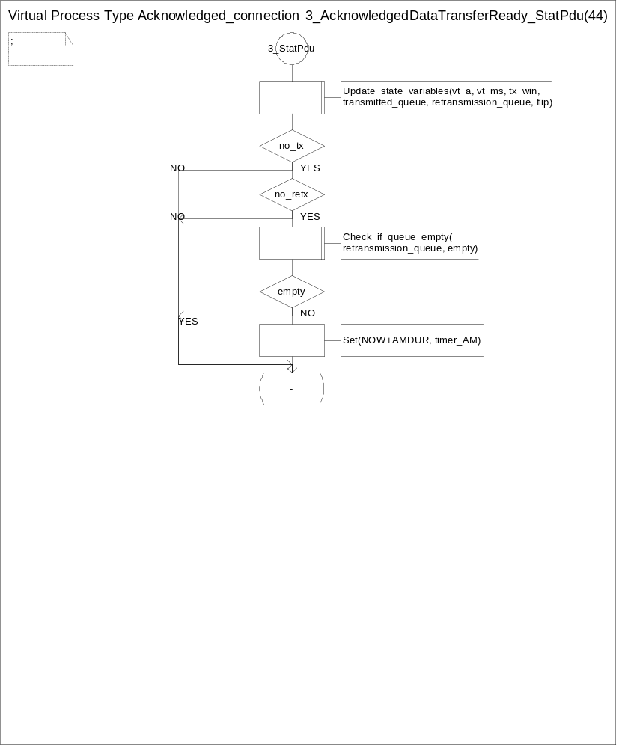
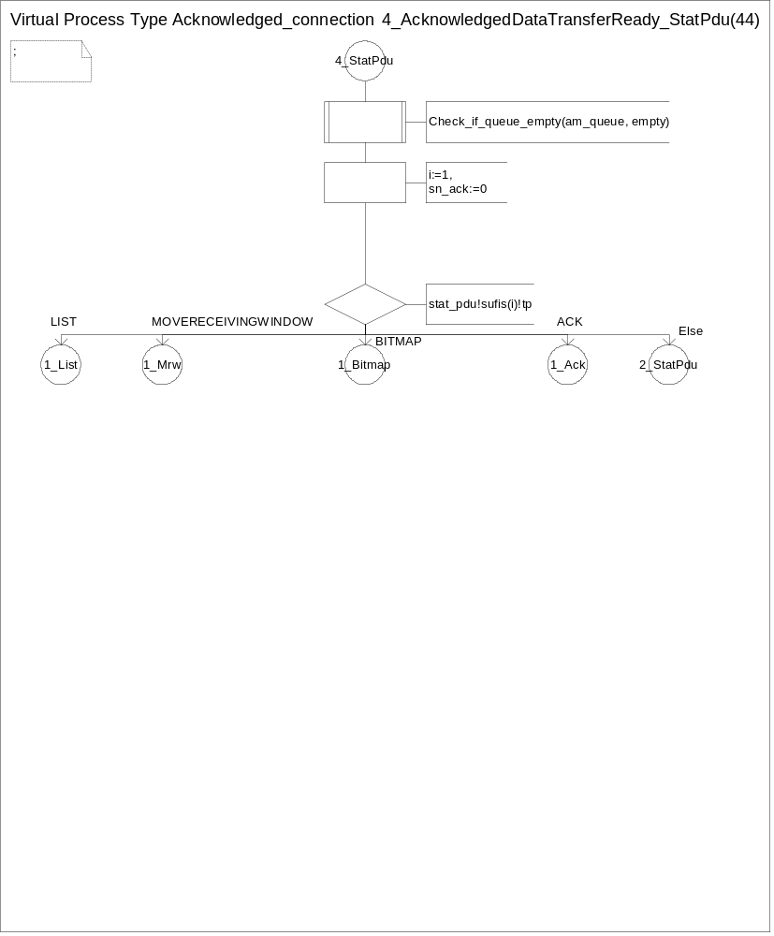
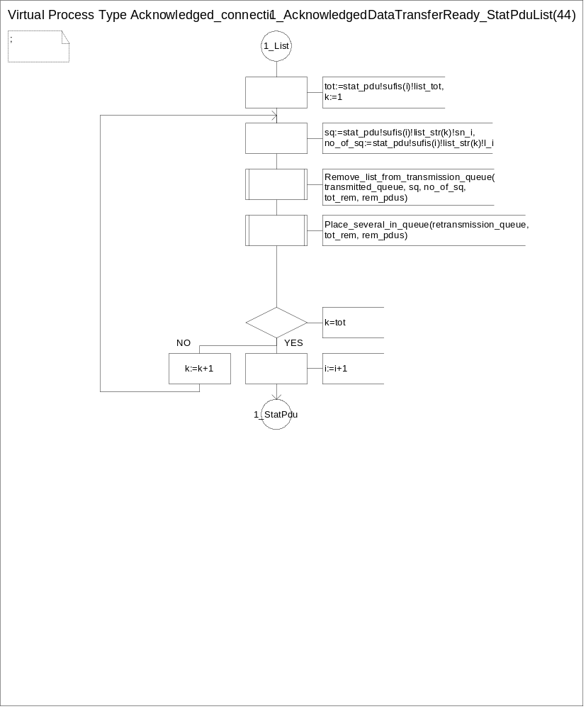
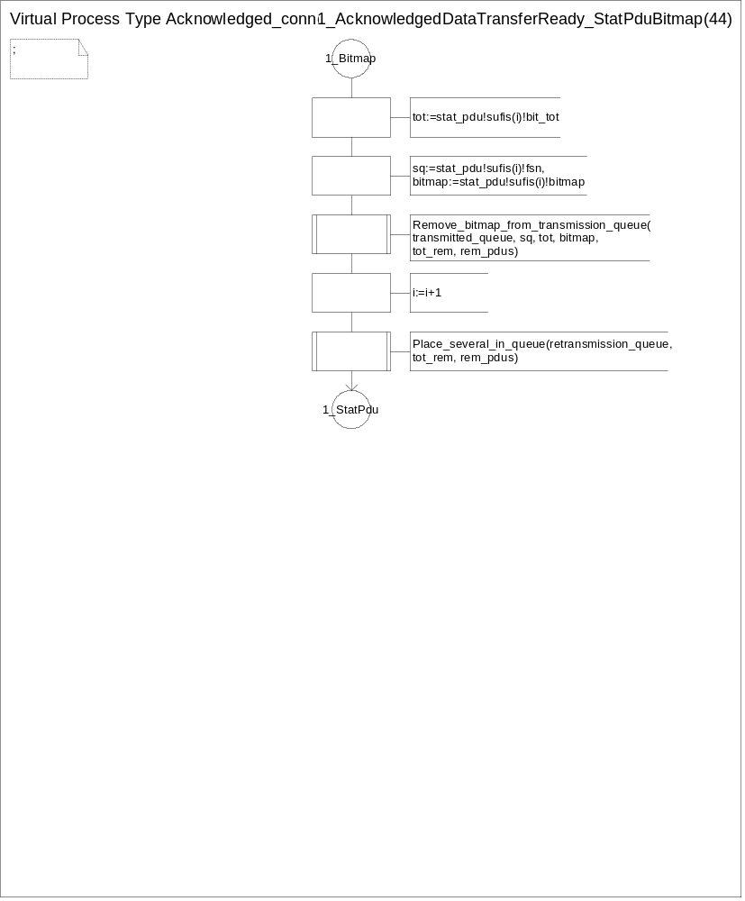
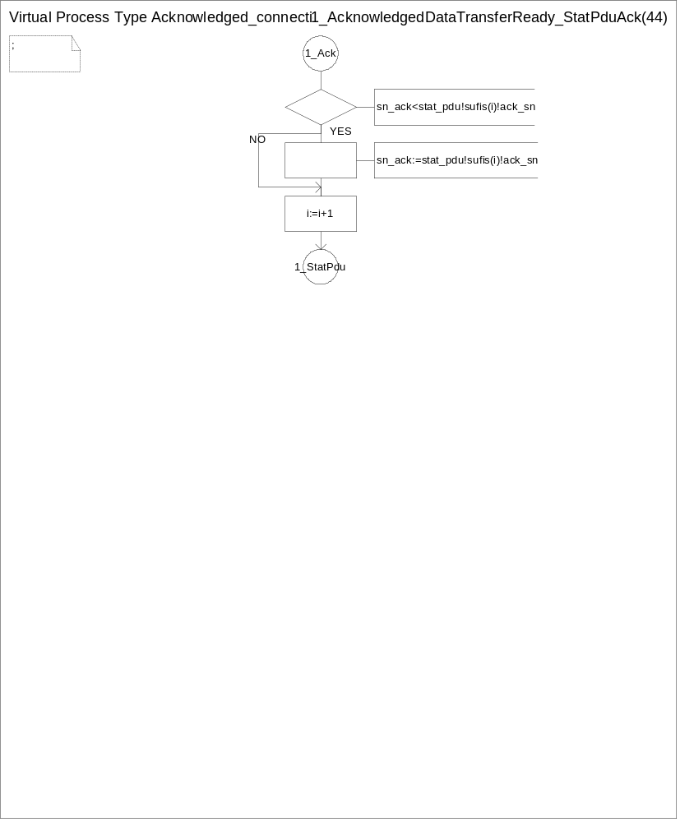
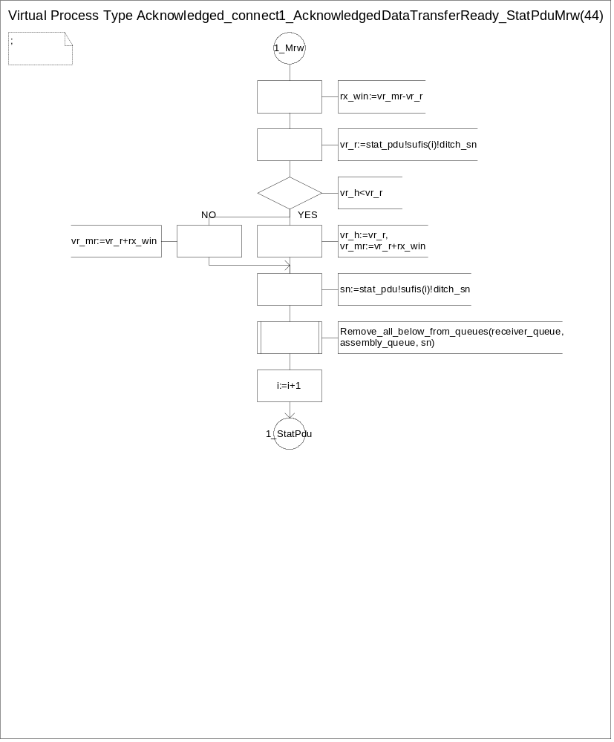
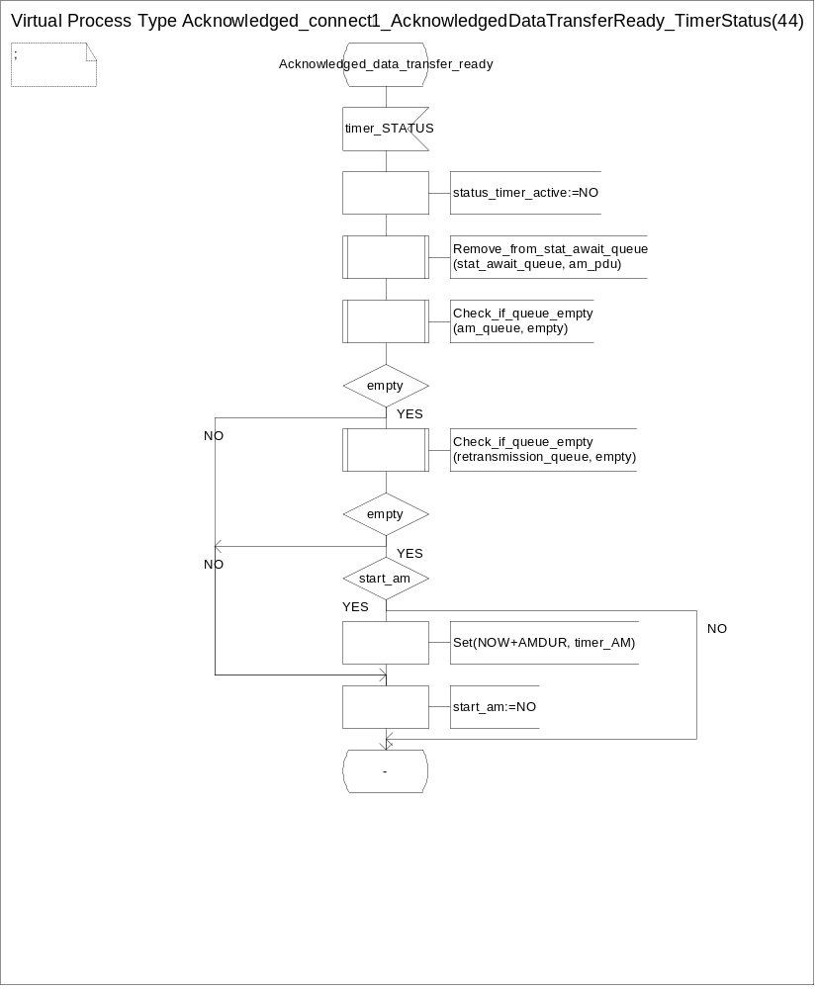
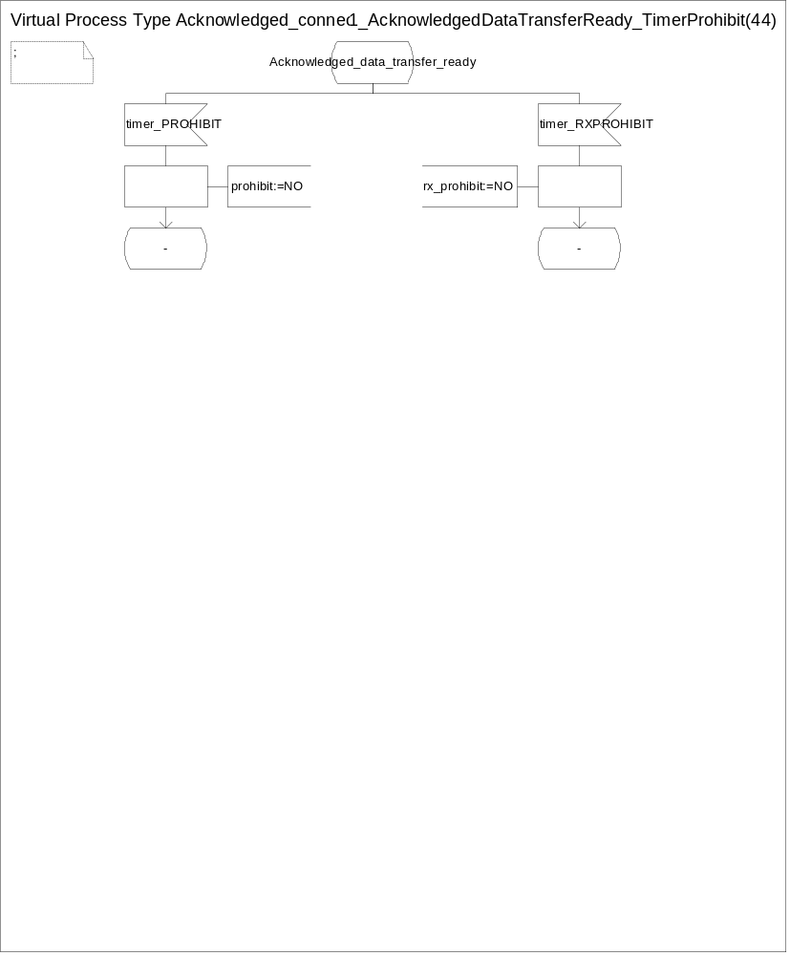
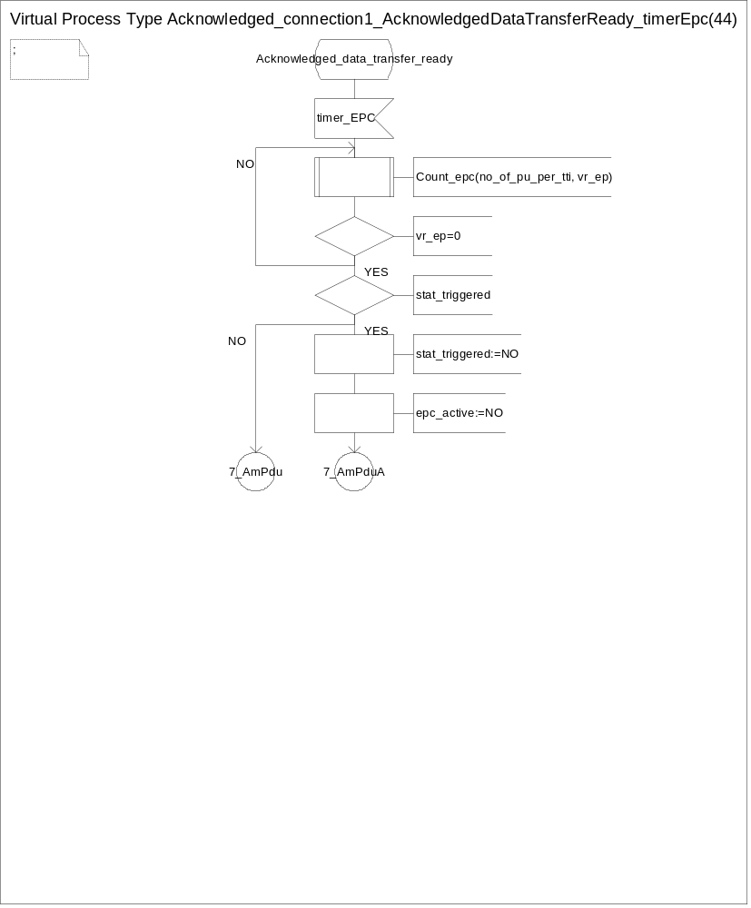
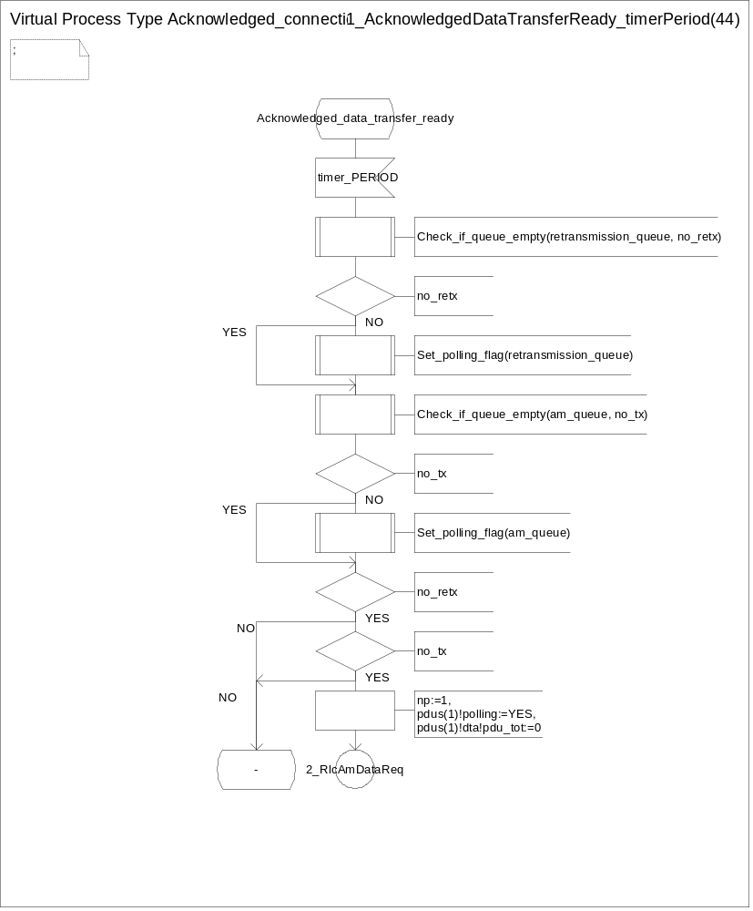
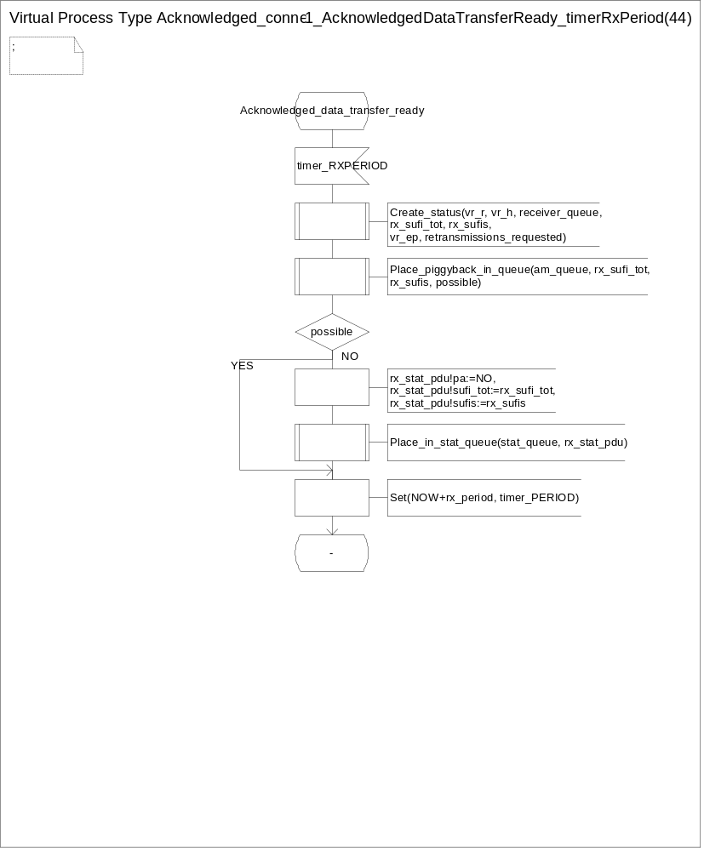
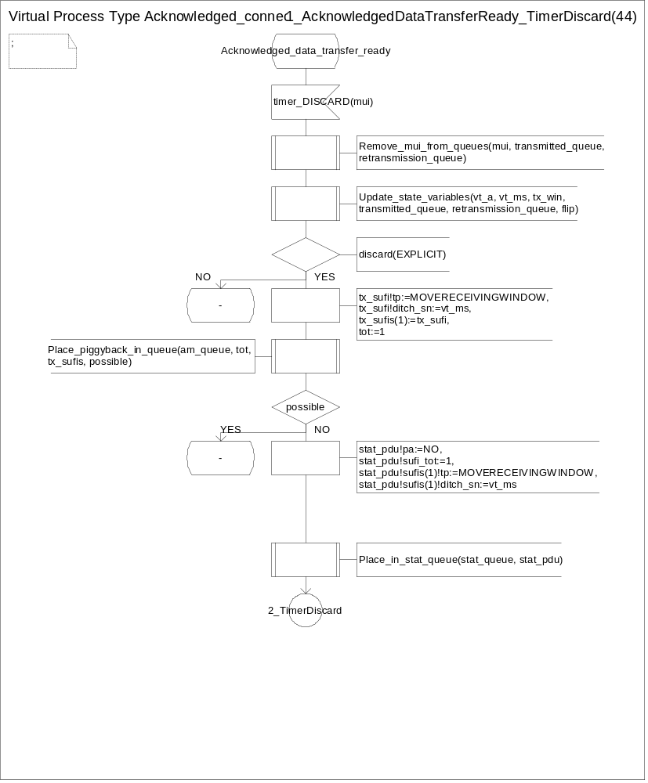
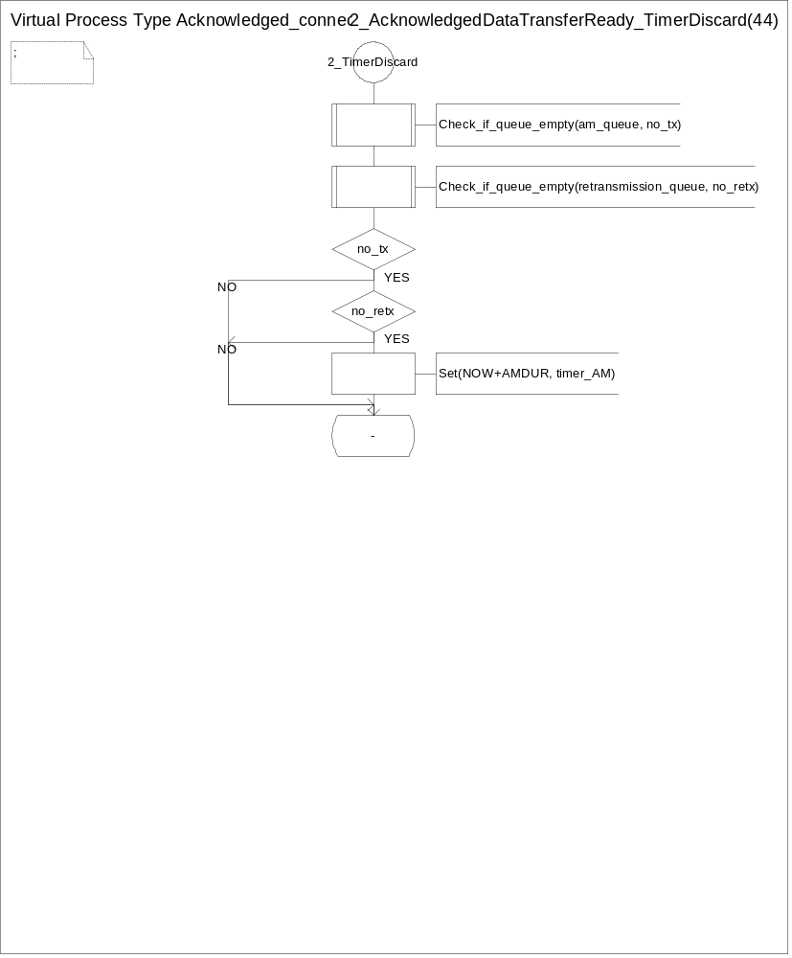
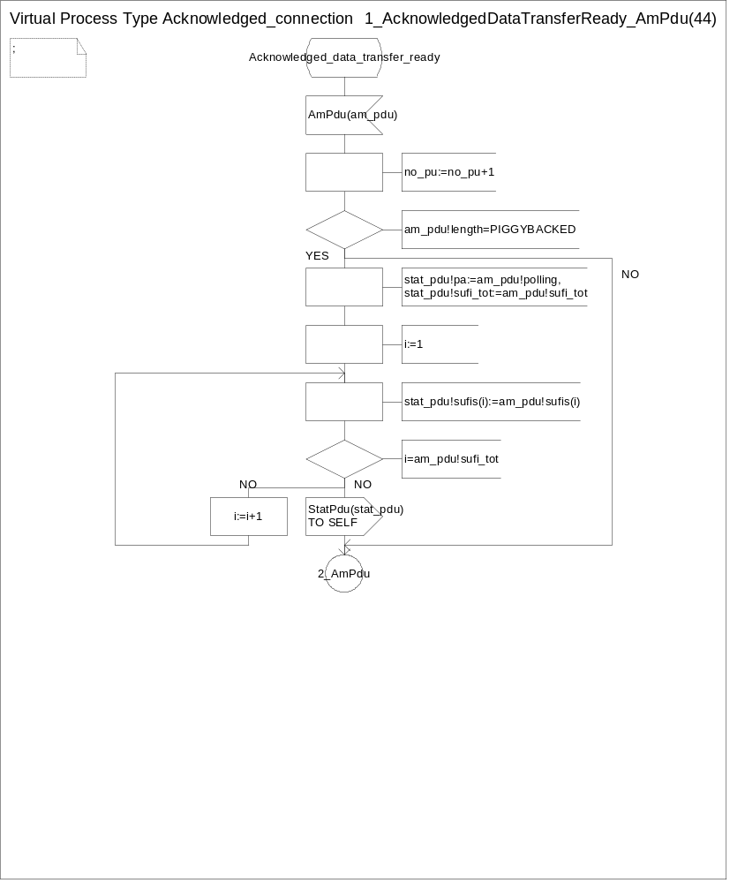
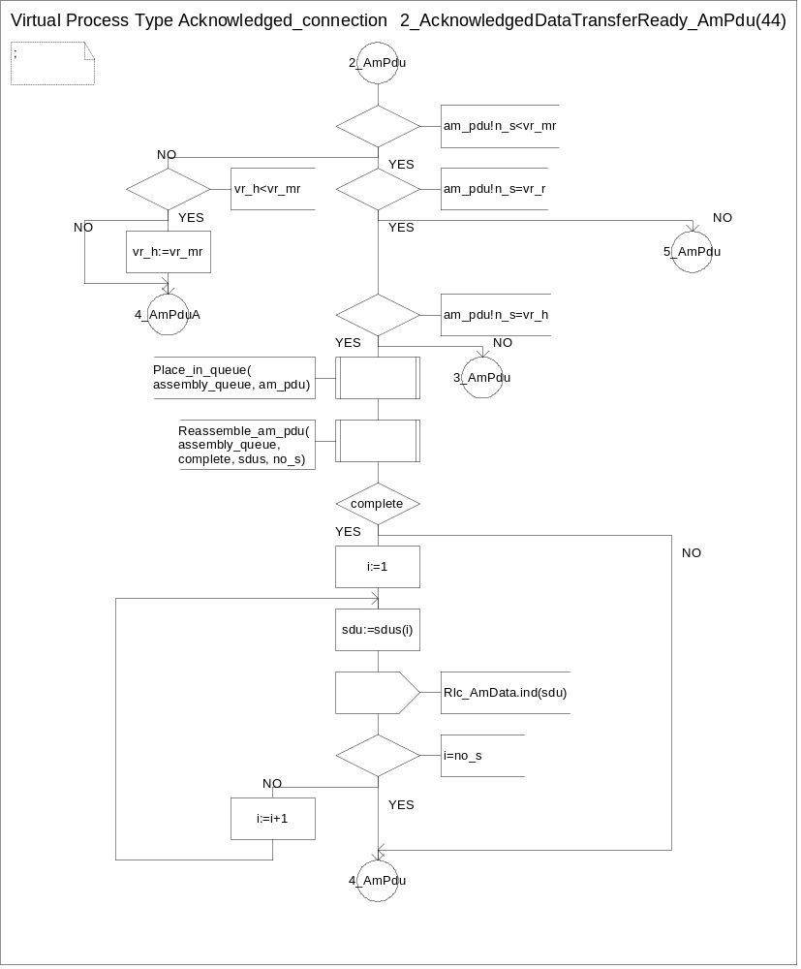
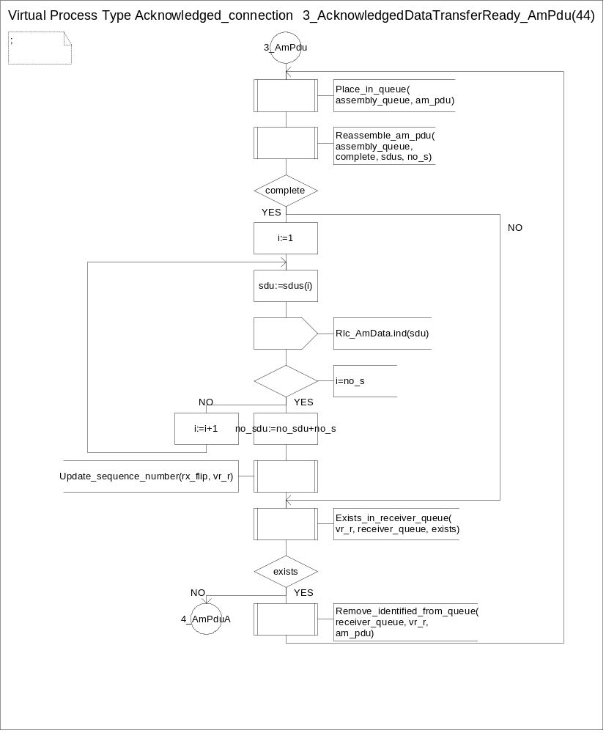
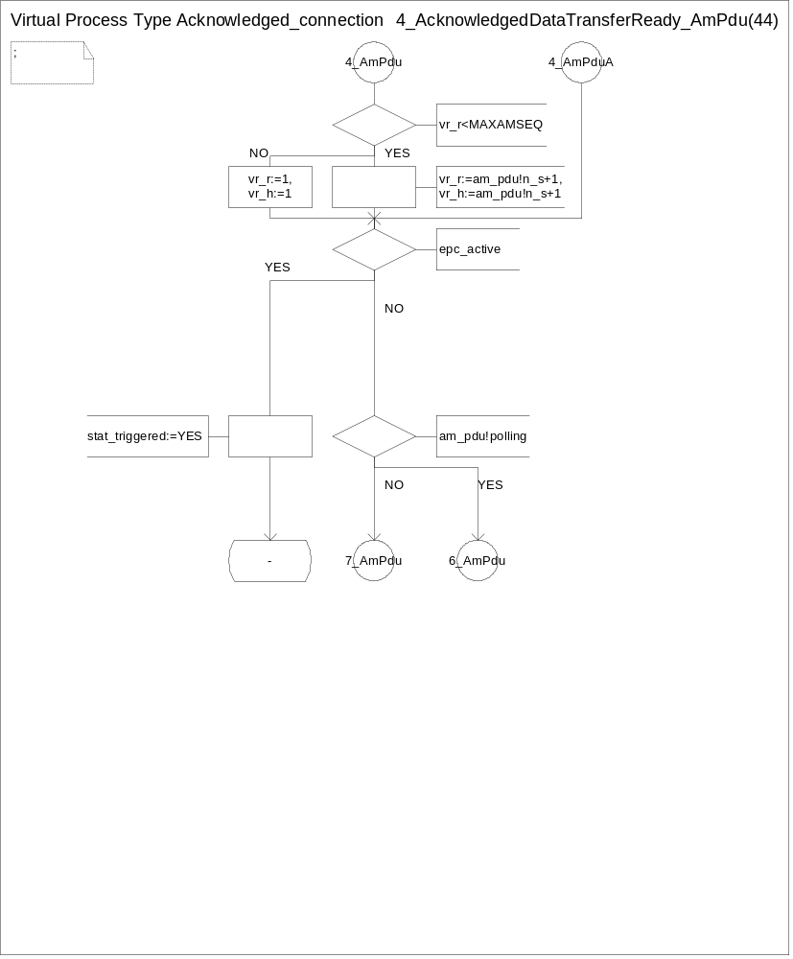
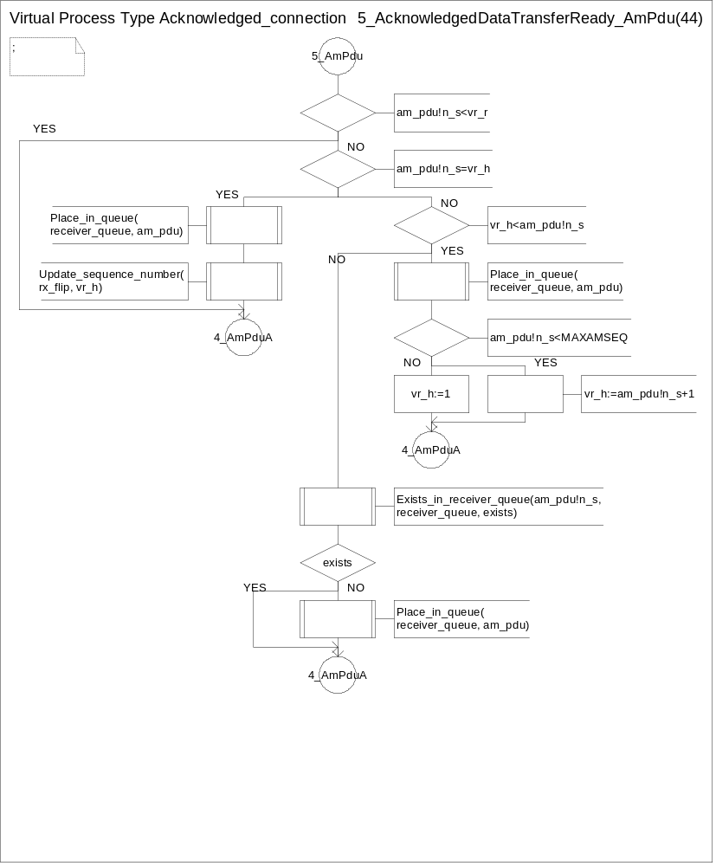
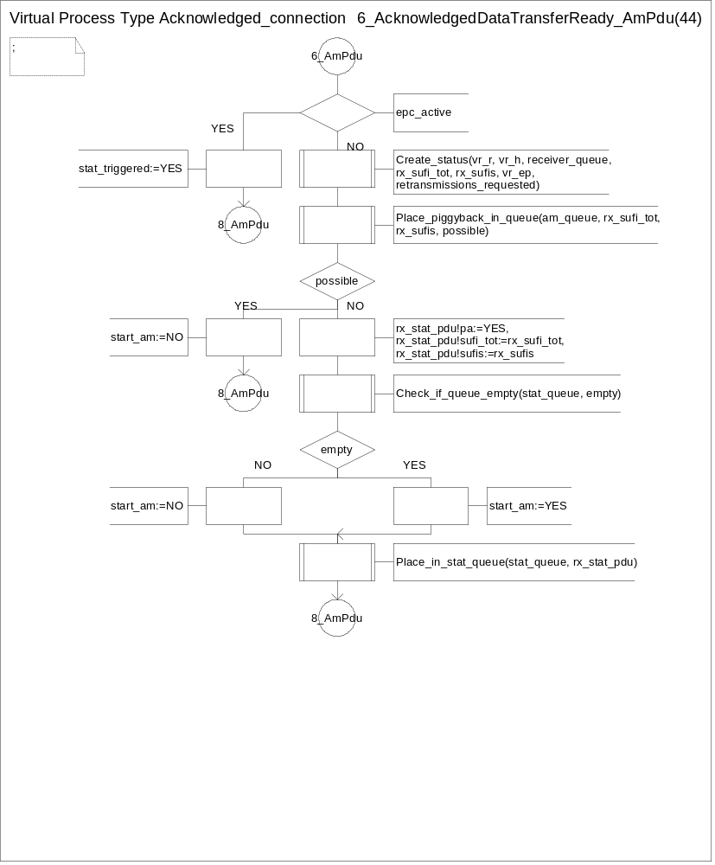
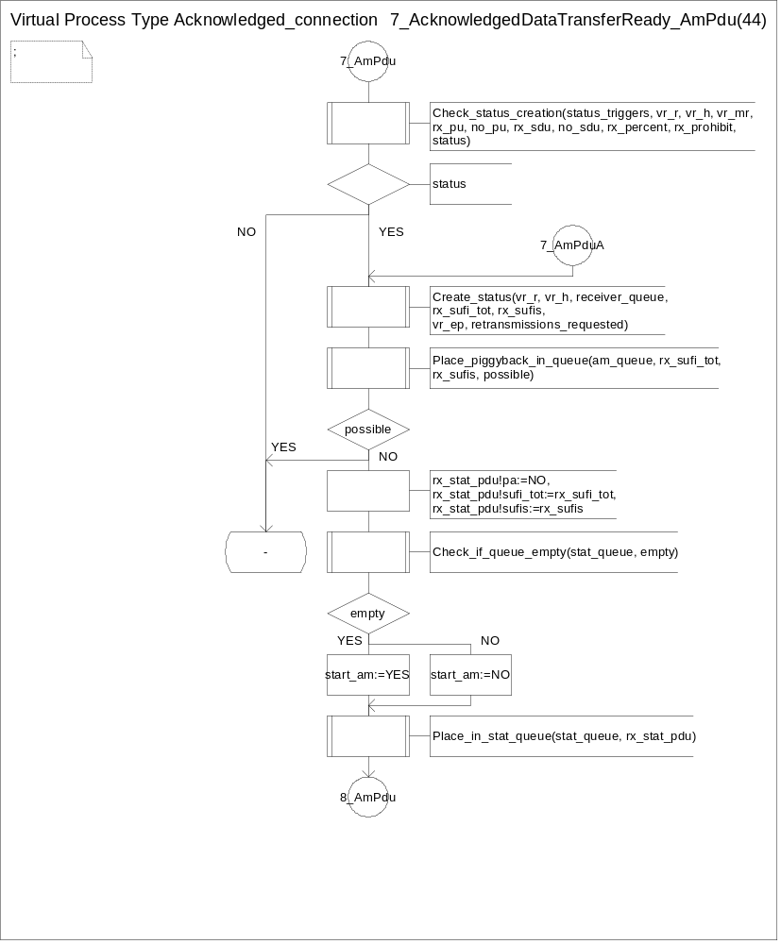
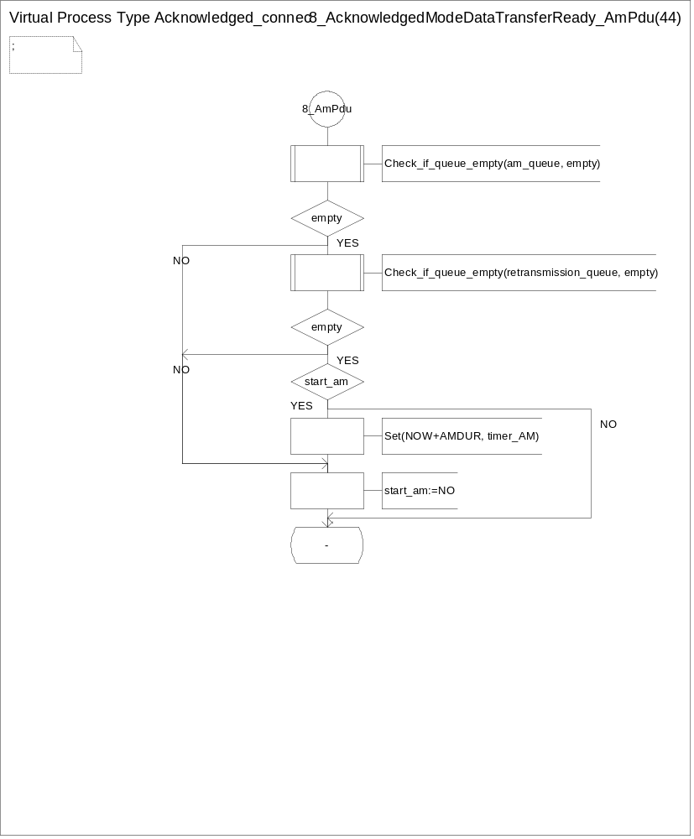
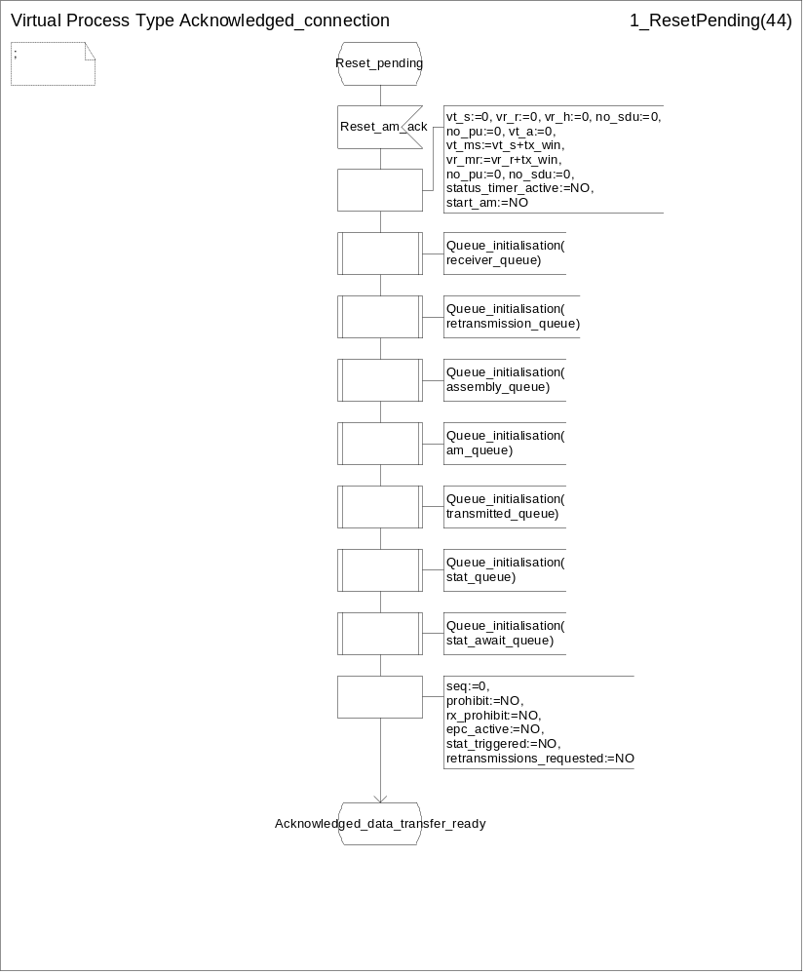

Appendix

1. Recommended values
1.1 PDU length
The length of the data field in AMD / UMD PDUs is k ( >=0 ) octets.

4

1.3 MaxDAT
[FFS]

1.4 MaxQR
[FFS]

1.5 MaxSTATUS
This parameter should be an odd integer greater than or equal to 3.

1.6 Timer_STATUS
[FFS]

1.7 Timer_Prohibit
[FFS]

1.9 Timer_QR
[FFS]

Annex A Pseudo code describing AMD PDU header Compression
The following Pseudo-Code is an example of algorithm to describe the exact Header Compression Operation that takes place when several PUs are packed into one RLC PDU.

/* Prior to calling this procedure it must be checked that <pus_in_pdu> consecutive PU:s
are to be transmitted (or there is padding in the end)*/

Compress_PDU (pus_in_pdu, pu_size) {

li_addition = 0; // reset the variable that counts data in full pu:s

Loop through pus_in_pdu {

d_e_flag = E-flag for this PU;

If (d_e_flag == FALSE) {

Append PU data to PDU data; // complete PU is SDU-data
li_addition += pu_size; // to be added to the next LI

} else { // E-flag is TRUE, so LI-field(s) exist

Previous E-flag in PDU = TRUE; // Either in PDU header or pdu_li_vector;

j = 0; // reset LI-counter for this PU
pu_data_size = 0; // reset data size counter for this PU

Loop until (d_e_flag == FALSE) {

d_li = next LI; // in octet j of PU;
d_e_flag = next E_FLAG; // in octet j of PU;

if (d_li is not PADDING) {

pu_data_size += d_li; // to keep track of data segment size in this PU);
d_li += li_addition; // to add data from previous PU:s to LI-value);
li_addition = 0; // reset li_addition;

}

Append (d_li + d_e_flag) to pdu_li_vector;

j++; // go to next li_octet, if d_e_flag is TRUE);

} /* end-of-loop (exit when d_e_flag is TRUE) */

Append pu_data_size segments starting from j to RLC-PDU data;

} /* end-of e-flag == TRUE */

} /* end-of loop through PU:s in PDU */

} /* end-of Compress_PDU */

History
Document history
Date | Version | Comment
June 1999 | 1.0.0 | Based on the discussion on CWTS WG1 #3 meeting in CUPT
August 30th,1999 | 2.0.0 | Based on the discusssion on CWTS WG1 Ad Hoc1 #3,Beijing
October 14th ,1999 | 2.1.0 | Based on the discusssion on CWTS WG1 Ad Hoc1 #4 and CWTS WG1 #5,Beijing
Rapporteur of CWTS WG1 TS c202 is:
Editor:
Li Fangwei

CUPT
This document is written in Microsoft Word version 97.

